Unit 8: Classification
Study Guide Text: Unit 6: Diversity of Life (Chapters 18-23)
SB4. Obtain, evaluate, and communicate information to illustrate the organization of interacting systems within single-celled and multi-celled organisms.
a. Construct an argument supported by scientific information to explain patterns in structures and function among clade of organisms, including the origin of eukaryotes by endosymbiosis. Clades include:
- archaea
- bacteria
- eukaryotes
  - fungi
  - plants
  - animals
b. Analyze and interpret data to develop models (i.e., cladograms and phylogenetic trees) based on patterns of common ancestry and the theory of evolution to determine relationships among major groups of organisms.
c. Construct an argument supported by empirical evidence to compare and contrast the characteristics of viruses and organisms.
- Draw and label a virus. Include the protein coat/viral capsid, and nucleic acids.

- What is the function of a viral (protein) capsid?

- What is the main difference between lytic and lysogenic viruses?

- Which letter indicates the stage at which…
  - a bacteriophage injects DNA into a host cell? _______
  - a host cell begins producing new bacteriophage? _______
  - the bacteriophage DNA becomes part of the host cell’s DNA? ______
  - In which cycle is the host cell destroyed? _______

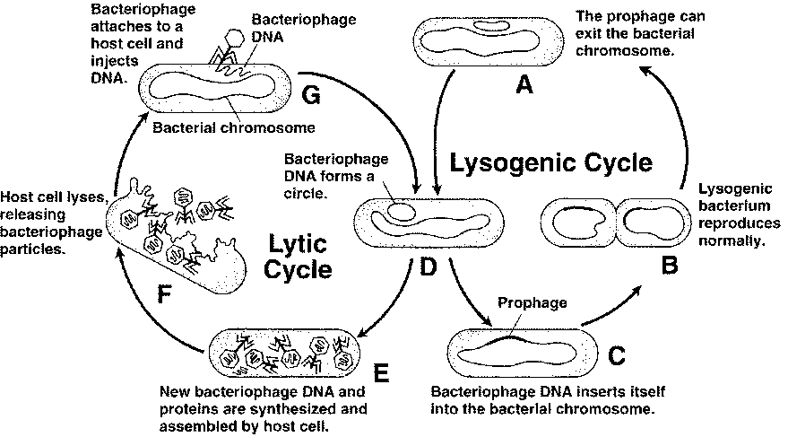

- Why are viruses considered nonliving?

- What is binomial nomenclature & how is it written?

- List the taxa in order from broadest to most specific.

- What is the difference between Eubacteria and Archaebacteria?

- Fill in the following chart:
Kingdom | Prokaryotic/  Eukaryotic | Multicellular/  Unicellular or BOTH | Autotroph/  Heterotroph or BOTH | Examples
Archaeabacteria (ancient bacteria)and Eubacteria

Bacteria

Protista

Fungi

Plantae
(plants)

Animalia
(animals)

- Similar genes (DNA & RNA) are evidence of what?

Cladogram Analysis
What is a cladogram? It is a diagram that depicts evolutionary relationships among groups. It is based on PHYLOGENY, which is the study of evolutionary relationships. Sometimes a cladogram is called a phylogenetic tree (though technically, there are minor differences between the two).
In the past, biologists would group organisms based solely on their physical appearance. Today, with the advances in genetics and biochemistry, biologists can look more closely at individuals to discover their pattern of evolution, and group them accordingly - this strategy is called EVOLUTIONARY CLASSIFICATION
CLADISTICS is form of analysis that looks at features of organisms that are considered "innovations", or newer features that serve some kind of purpose. (Think about what the word "innovation" means in regular language.) These characteristics appear in later organisms but not earlier ones and are called DERIVED CHARACTERS.
A clade is a grouping or branch that includes a common ancestor and all the descendants (living and extinct) of that ancestor.
11. Define phylogeny.________________________________________________________________
_________________________________________________________________________________
12. Why is a cladogram sometimes called a phylogenetic tree?_______________________________
_________________________________________________________________________________________________________________________________________________________________
13. How were organisms grouped BEFORE advances in genetics and biochemistry?_______________
_________________________________________________________________________________
14. What is cladistics?_______________________________________________________________
_________________________________________________________________________________
15. What are derived characters?______________________________________________________
_________________________________________________________________________________
Cladogram #1
- Which 2 plant groups would be MOST closely related?
________________________________________________
- Which 2 plant groups would be most DISTANTLY related?________________________________________________________
- How do you know?____________________________________________
________________________________________________________________
- What adaptations developed after Ferns?
________________________________________________________________________________________________________________________________________________________________________________________________________
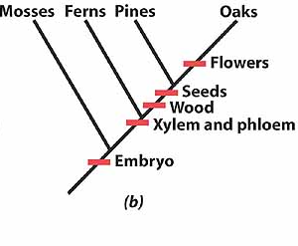

Cladogram #2
20. What animals does not have jaws?
________________________________________
21. Which animals have lungs?
_____________________________________________________________________________________________________________________
22. Which of the following groups, taken by themselves, do NOT form a clade?
a. Pidgeon, Mouse and Chimp
b. Lizard, Pigeon and Mouse
c. Salamander, Lizard, Pigeon, Mouse and Chimp
d. Hagfish, Perch, Salamander, Lizard, Pigeon, Mouse and Chimp

- What is a Cladogram? What does it show?________________________________________________________________
_________________________________________________________________________________________________________________________

What should I use to study for my test?
- Powerpoint notes on the blog
- This study guide

