Name: ________________________ Date: _________________ Period: ______________ ATP, Photosynthesis and Cellular Respiration Web quest

Objective: In this web quest investigation, you will use the internet to research topics related to ATP, Photosynthesis and Cellular Respiration. Use the web links provided to answer the following questions. Happy searching!

What is ATP? http://www.biologyinmotion.com/atp/index.html

- How does energy get converted from food molecules to muscles? __________________________________________________________________________________
- According to the webpage, the analogy for ATP is that ATP works like a rechargeable _________________.
- Click on the arrow to the next page. Pull apart the ice cream. What happens when food is broken down in the body? ___________________________________________________________________
_______________________________________________________________________________________

What is Photosynthesis? http://www.biology.ualberta.ca/facilities/multimedia/uploads/alberta/Photo.html
- Where on the plant does photosynthesis take place?________________________________________
- The energy from the sun enters into what organelle in the plant? _____________________________
- How does the plant get water for photosynthesis? __________________________________________
- What gas enters the plant for photosynthesis?_____________________________________________
- Where does it enter the plant?__________________________________________________________
- What gas exits the plant during photosynthesis?___________________________________________
- Where does it exit the plant? ___________________________________________________________
- WRITE the overall equation for photosynthesis below.

Overview of Photosynthesis Labeling. Label the following picture below.
http://www.phschool.com/science/biology_place/biocoach/photosynth/overview.html
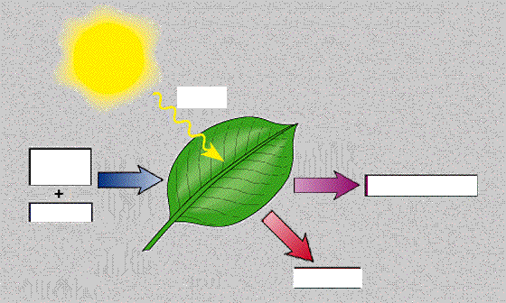

What is Cellular Respiration? http://www.biology.iupui.edu/biocourses/N100/2k4ch7respirationnotes.html
12. What is the definition of Cellular Respiration?(in purple)_______________________________________
__________________________________________________________________________________________
13. What happens during cellular respiration? __________________________________________________
__________________________________________________________________________________________
14. WRITE the equation for Cellular Respiration below.

