Name(s):______________________________ Date:_____________________ Period:________
Natural Selection Lab- PhET Simulation
http://phet.colorado.edu/simulations/sims.php?sim=Natural_Selection (biol.co/2wolf2)
**Exploration of the Simulation
Access the simulation and explore the settings. Answer the following questions
Pre-Lab Questions
- What variables can you influence in this lab?___________________________________
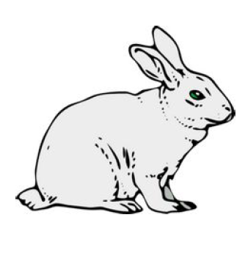
____________________________________________________________________________
- Define what a genetic mutation is. How do genetic mutations happen? How often?_________________________________________________
___________________________________________________________
___________________________________________________________
___________________________________________________________
- What do the terms fitness and adaptation mean? What is the difference between the two?
____________________________________________________________________________
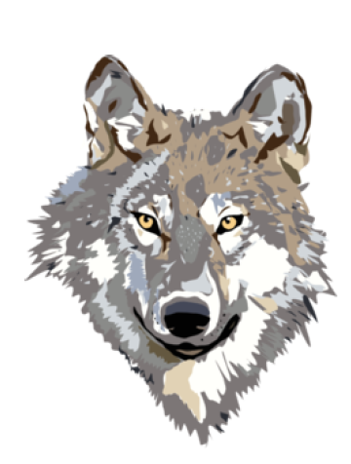
____________________________________________________________________________
- What selection factors might effect an animal population besides the ones used in this lab?__________________________________________
____________________________________________________________
____________________________________________________________
Designing The Experiment
In this Lab you will be controlling the mutations and environment of a population of rabbits. Your will create three hypotheses and design an experiment to test each one. Your hypothesis will follow the format where you fill in the (...) with your own ideas and reasons.
Problem: Which color of rabbit will have higher fitness and get food in the equator environment, when there is NO predator?
- I hypothesize that (_______________________) rabbits will be (____________________) likely to survive and get food within the (____________________) environment without a predator, because ______________________________________________________.

Problem: Which color of rabbit will have higher fitness and get food in the equator environment when a predator is present?
- I hypothesize that (_______________________) rabbits will be (____________________) likely to survive and get food within the (____________________) environment WITH a predator, because ______________________________________________________.

Problem: Which teeth shape will have higher fitness and get food in the equator environment?
- I hypothesize that the rabbit with _______________ teeth will be _____________________likely to survive in the __________________________ environment with a predator, because ________
_______________________________________________________________________________
For each experiment you must have a control (no mutation) and fill in the following chart.
- For each of the experiments, begin by adding a friend and a mutation. Wait until the F3 generation before adding the selective factor. After adding the selective factor let the simulation run for another 3 or 4 generations.
- Use the population numbers from the chart to get you numbers for the table, remember you can zoom in and out on the chart to get more accurate reads.
- Repeat for experiments 2 and 3
Experiment  and  Hypothesis | Phenotype | Selective Factor | CONTROL  Group  Initial Population at F3 | CONTROL  Group  Final Population | Experiment  Group  Initial Population at F3 | Experiment  Group  Final Population | Conclusion/  Observation
1 | Brown rabbit | Food
2 | Brown rabbit | Wolves
3 | Long teeth | Wolves

Post-Lab Questions
- Based upon your evidence from the simulation what conclusion are you able to make about each of the different types of phenotypes in rabbits in the equator environment?
__________________________________________________________________________________________________________________________________________________________________________________________________________________________________________
- What happens to animals that cannot compete as well with other animals in the wild?
____________________________________________________________________________________________________________________________________________________________________
- Sometimes animals that are introduced into an area that they never lived in before, out-compete and endanger resident species, why do you think this happens?
______________________________________________________________________________________________________________________________________________________________________________________________________________________________________________________
- If only one species is considered the "fittest", why do we still have so many variations among species? Why do some birds have very long pointy beaks, while other birds have short flat beaks?________________________________________________________________________
____________________________________________________________________________________________________________________________________________________________
- How do you think diseases can affect natural selection?
____________________________________________________________________________________________________________________________________________________________
- How does this simulation mimic natural selection? In what ways does this simulation fail to represent the process of natural selection?__________________________________________
____________________________________________________________________________________________________________________________________________________________________
- How would your results change if you used the arctic environment instead? Explain your answer using the process of natural selection_________________________________________________
__________________________________________________________________________________
____________________________________________________________________________________________________________________________________________________________________

