Information about the Biology End-of-Course Assessment.

- What is the EOC? The end-of-course assessment is a state-written assessment given to all students in Biology in order to assess their understanding of the content in comparison to students at other schools in the state. It is a required test that is not allowed to be exempted and must be made up.

- When is the Biology EOC? Fall Testing is Monday December 9th & Tuesday December 10th.

- How much does it count? The EOC counts 20% of your overall grade in Biology this semester & will be reflected on your permanent transcript.

- What can I expect the EOC to be like? We take the EOC in 2 parts on 2 back-to-back days. It is computer based and timed. Questions vary from multiple choice, matching, and choosing more than one right answer. As far as we know, there are not any free-response questions on the Biology EOC.

- How is the content broken down? How much of each topic will the test be made up of? The EOC is broken into 5 major domains in which a percentage of the test will be dedicated to each domain.
See the breakdown below.

Domain | Standard | Approximate Weight
Cells | SB1 | 18%
Genetics | SB2 & SB3 | 25%
Organisms | SB4 | 17%
Ecology | SB5 | 25%
Evolution | SB6 | 15%

- Do I get a study guide? YES-it is attached to the back of this and will have due dates for each unit.

- What should I study to prepare? The review packet attached to this handout and your old study guides will help you prepare for the eoc. Also Google: Biology EOC GA and click on the link that says: Biology EOC Study/Resource Guide-GA Department of Education for another study resource.

Name: ______________________________________________________________________________________

Unit 1: Ecology
- Draw an energy pyramid and label the following: trophic levels, high and low number of organisms, high and low biomass, 10% rule, heterotrophs, autotrophs, cellular respirators, photosynthesizers, examples of species.

- Explain how much energy is available at each succeeding level in an energy pyramid. (The 10% rule). Explain what the energy is “lost” to.

- What is the difference between a niche and a habitat?

- List the levels of organization in ecology beginning with the individual and ending with the biosphere. Give an analogy for each level (example: organism=student at Hillgrove high school).

- Define symbiosis.

- Describe the three types of symbiosis and give at least one example for each.
Type of Symbiosis | Description | Example

- What is the ultimate source of energy?

- Draw a graph that demonstrates the population size changes of a predator/prey relationship. Explain why the population changes occur.

- Describe primary succession. Give 2 examples.

- Describe secondary succession. Give 2 examples.

- Describe 2 environmental problems caused by the burning of fossil fuels. How does this involve the carbon/oxygen cycle?

Unit 2 Introduction to Science & Biochemistry
- Define qualitative and quantitative data. Give an example of each.

- A pharmacologist is testing whether a new anti-anxiety medication, Moodcor, will cause people to gain weight. To test this, she gives 100 people Moodcor for one month and 100 people a placebo drug. At the end of the month, she monitors any weight gain. What is the:
-Independent variable: _____________________________

-Dependent variable: _______________________________

-Draw a graph and place each variable on the correct axis

- The pH range for acids is ____________, for bases is ____________, and neutral pH is _____.

- Complete the chart below
 | Carbohydrates | Lipids | Proteins | Nucleic Acids
Monomer |  | Fatty acids and glycerol
Function(s)

Picture  Example | 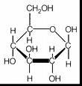 | 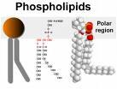 | 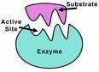 | 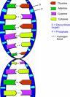

- What macromolecule are enzymes? What do enzymes do for reactions?

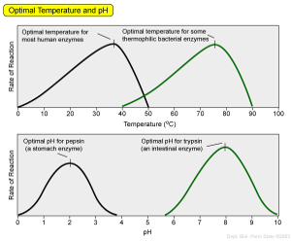
6. In the graph above, at which temperature do the 2 enzymes have the SAME activity level (rate of reaction)?_______

7. In the graph above, which enzyme (black or green) would most likely be found in a basic environment?__________

Unit 3 Cells
1. What is ATP? How is energy released from ATP?

2. (Circle the correct choice) Hetertrophs/Autotrophs undergo photosynthesis,
or
Heterotrophs/autotrophs undergo cellular respiration.

3. Photosynthesis occurs in _____________________ (organelle), cellular respiration occurs in
_____________________ (organelle).

4. Write out the equations for photosynthesis & cellular respiration. Circle the reactants & square the products.
  - Photosynthesis-

  - Cellular respiration-

B
5. 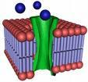
A

  - What is the function of the protein labeled A?

  - Draw an arrow pointing to the area of the phospholipid bilayer where you are least likely to find water (hydrophobic, nonpolar section).

  - If the molecules labeled B are glucose moving from high concentration to low concentration, what process is occurring?

6. What are two differences between active and passive transport?

7. List and describe the 3 types of passive transport.

8. List and describe the 3 types of active transport.

9. What would happen if you place a cell in a hypotonic solution?

10. Create a Venn diagram that compares and contrasts prokaryotes and eukaryotes.

11. Complete the chart below:
Picture | Cell part name | Function
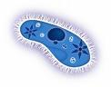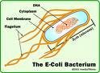 | Cilia  Flagella
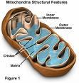 |  | Converts sugar to energy
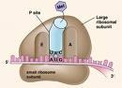 | Ribosomes
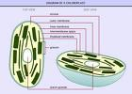 | Chloroplast
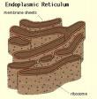 | Rough endoplasmic reticulum
 |  | Packages proteins and lipids for export from the cell

Unit 4: Cell Division

- Draw a picture of two chromatids attached at the centromere.
Label the centromere and sister chromatids.

- Complete the chart for mitosis and meiosis.
 | Mitosis | Meiosis
Type of cells produced
Chromosome number
(n or 2n)
How do they compare to original parent cell?

- What stage of the cell cycle is DNA replicated for mitosis and meiosis?

- What is the function of the spindle fibers?

- If a body (somatic) cell of an organism has 28 chromosomes, how many will be present in its gametes (sperm & egg)?

- What is crossing over? Why is it important in sexual reproduction?

- The stages of mitosis are shown out of order below. Label them with the correct name and put a number next to each to show the correct order, beginning with prophase.
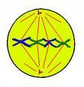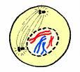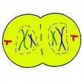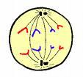

___________ ___________ __________ __________

- What is cancer? Draw a graph that would show normal cell growth as compared to cancerous cell growth.

Unit 5: Mendelian Genetics
- What is a heterozygous (hybrid) genotype? Give an example.

- What blood type is I^{B}I^{B} or I^{B}i?

- Cross I^{A}i with I^{B}i (Show your punnett square). Give the phenotypic and genotypic ratios.

Genotype Ratio ________________________

Phenotype Ratio ________________________

- If an individual has Downs Syndrome, they have trisomy of which chromosome? How does nondisjunction cause Downs Syndrome?

- Black hair color in rats is determined by a simple dominant allele (B = black), while white hair color is determined by a recessive allele (b = white). Cross a heterozygous black male with a white female rat (Show your punnett square). State the genotypic AND phenotypic ratios.

Genotype Ratio ________________________

Phenotype Ratio ________________________

- Flower color in snapdragons is determined by incomplete dominance. If a homozygous red flower crosses with a homozygous ivory flower, the phenotypic outcome for F1 is 100% pink. Predict the phenotype & genotype percentages for the F2 generation.

Genotype Percentage ________________________

Phenotype Percentage ________________________

- Draw a pedigree showing 3 generations, with at least 2 normal females, 1 affected female, 1 carrier female, 3 normal males, & 1 affected male.

Unit 6 Molecular Genetics

- In DNA replication A pairs with ________, T pairs with __________, G pairs with ________, and C pairs with ________.
- In transcription (DNA is used to make ____________). A pairs with _________, T pairs with _________, G pairs with __________, C pairs with __________.

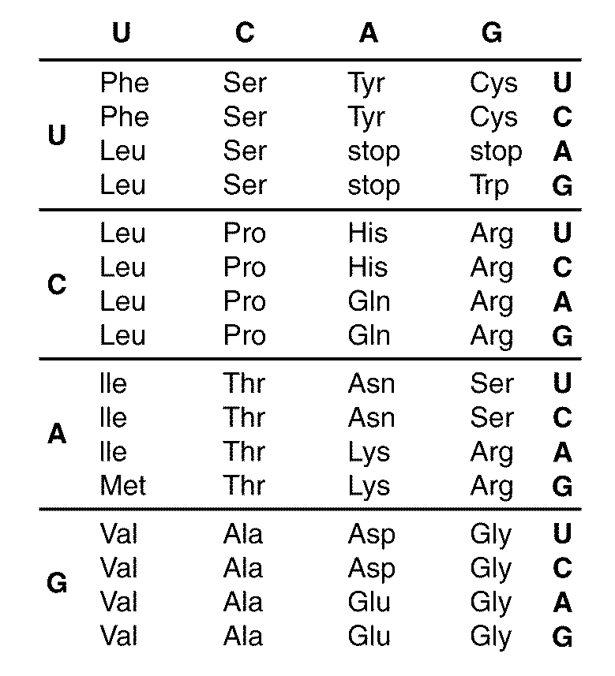

- What amino acid sequence does AUG-AAC-GGA code for?

- What would be the strand of DNA that this mRNA sequence would come from?

- What type of mutation happens when one base is deleted?

- What type of mutation happens when one base is replaced by another?

- What is recombinant DNA?

- What is a clone?

- Label the following picture:
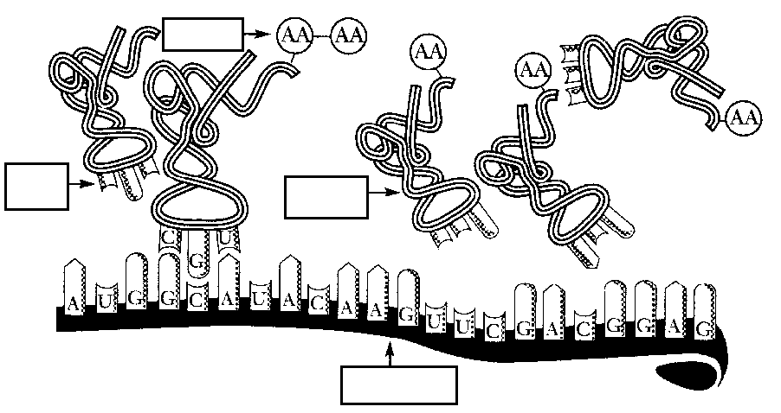

- (See above picture) Where does this process occur?

- Put the following in order from largest to smallest: chromosome, nucleus, cell, DNA, nucleotide

Unit 7 Evolution

- Explain Darwin’s theory of evolution using giraffes with short and long necks as an example. Make sure you include the following terms: adaptation/adapted, fitness, environment, survival of the fittest, and offspring.

- What is camouflage?

- What is genetic equilibrium? 5 conditions of what principle must be met for genetic equilibrium to occur?

- What is a gene pool?

- What is the founder effect?

- What is the bottleneck effect?

- What is geographic isolation?

- Identify the 3 types of natural selection indicated by each graph; make sure you include written descriptions of each.
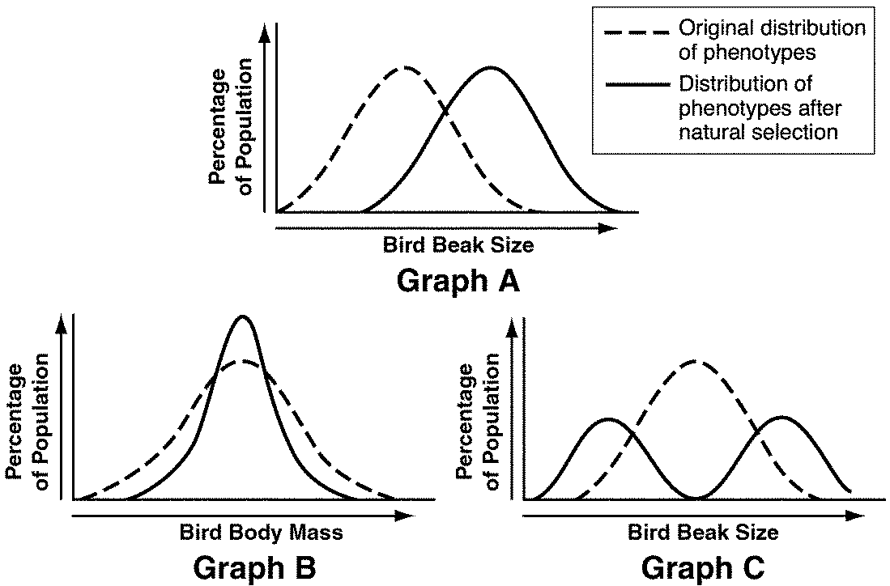

- How does convergent evolution lead to analogous structures?

Unit 8: Classification, Bacteria, and Viruses

1. List and describe the three domains and state which kingdoms are included in each.

2. List the 8 taxons from broadest to the most specific.

3. Which taxon contains the most organisms, which contains the least? Explain.

4. Which 2 kingdoms are prokaryotic? __________________& __________________ Which 4 kingdoms are

Eukaryotic? __________________, __________________, __________________& __________________

5. Contrast heterotrophs and autotrophs in 3 ways including examples of each.

6. What is the difference between a vertebrate and an invertebrate? Give an example of each.

7. What is a Cladogram? What does it show?

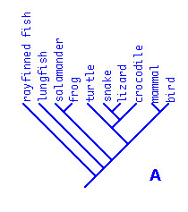
8. Using the cladogram, circle the correct answers below.

a. Salamander or lungfish is more closely related to the frog.

b. The turtle is less closely related to the lizard or ray finned fish.

9. Contrast the lytic and lysogenic cycles of viruses.

10. Complete the data table about each kingdom.

Feature | Eubacteria | Archaebacteria | Protista | Fungi | Plantae | Animalia
heterotroph/
autotroph
eukaryote/
prokaryote
3 examples
5 distinguishing features

