Monday April 22, 2019…….Earth Day-10 Days of Conscientious conservation

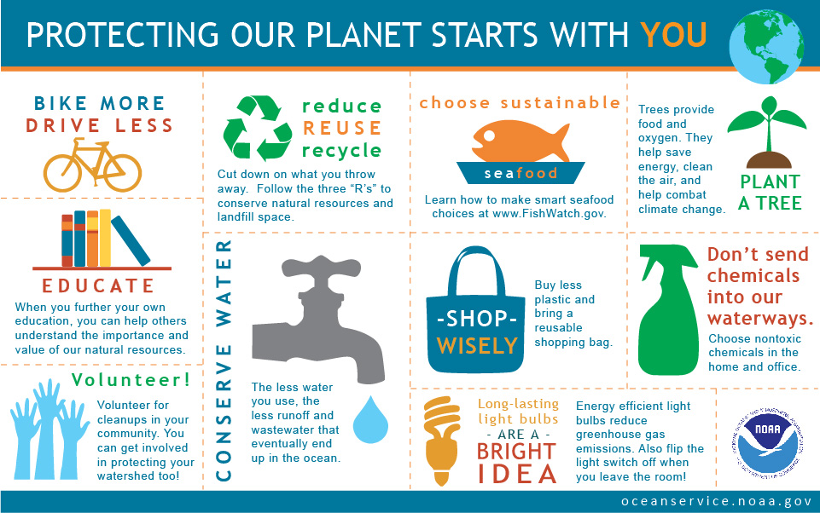
Starting Monday, April 22, record daily activities that you chose to do to better protect our Earth.
Each entry should have 1. Date and time of activity (10 total)
2. A complete sentence describing the specific activity. Example: I educated myself on sustainable seafood choices and found that the U.S. wild-caught mahi-mahi is a smart seafood choice because it is sustainably managed and responsibly harvested under U.S. regulations. (must use another example).
3. The category from the above chart the activity fits into. Example: choosing sustainable seafood

4. A 5 sentence reflection on your experiences and what you learned as you made the above choices. Try to include frustrations, conflicts, triumphs and surprises.

Monday April 22, 2019…….Earth Day-10 Days of Conscientious conservation

Starting Monday, April 22, record daily activities that you chose to do to better protect our Earth.
Each entry should have 1. Date and time of activity (10 total)
2. A complete sentence describing the specific activity. Example: I educated myself on sustainable seafood choices and found that the U.S. wild-caught mahi-mahi is a smart seafood choice because it is sustainably managed and responsibly harvested under U.S. regulations. (must use another example).
3. The category from the above chart the activity fits into. Example: choosing sustainable seafood

4. A 5 sentence reflection on your experiences and what you learned as you made the above choices. Try to include frustrations, conflicts, triumphs and surprises.

