Name:________________________________ Date:________________________ Period:____________
Unit 8: Classification

- Draw and label a virus. Include the protein coat/viral capsid, and nucleic acids.

- Draw a Venn Diagram that compares viruses and living bacterial cells.

- What is the function of a viral capsid (protein coat)?_______________________________________
__________________________________________________________________________________________
- Describe the difference between the Lytic cycle and lysogenic cycle of viruses. ________________
______________________________________________________________________________________
- Which letter indicates the stage at which…
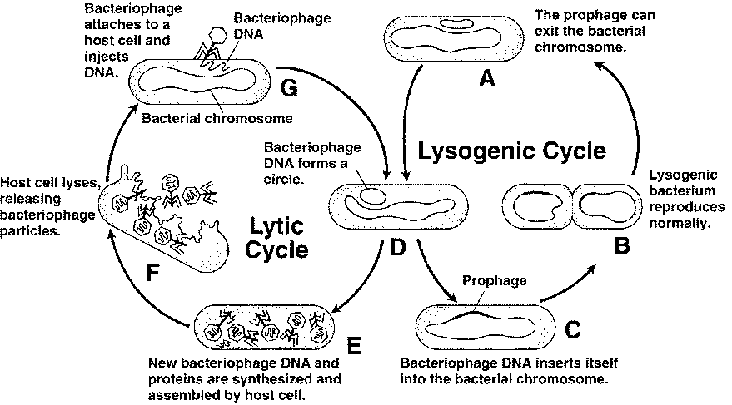
  - a bacteriophage injects DNA into a host cell? _______
  - a host cell begins producing new bacteriophage? _______
  - the bacteriophage DNA becomes part of the host cell’s DNA? ______
  - In which cycle is the host cell destroyed? _______
- What are examples of diseases caused by viruses?________________________________________
________________________________________________________________________________

- What is binomial nomenclature & how is it written?________________________________________
______________________________________________________________________________________
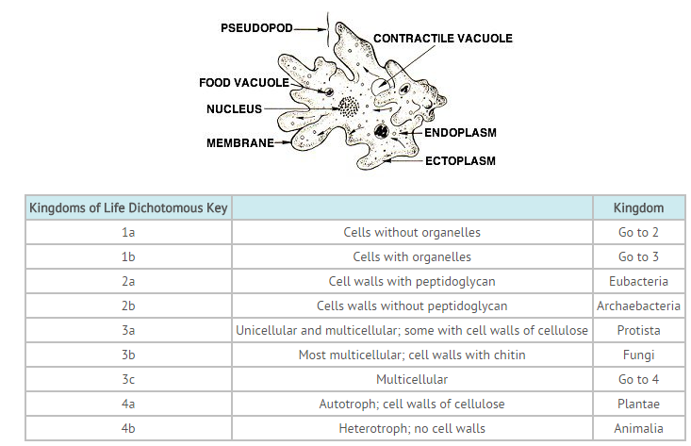
8. According to the dichotomous key, the amoeba seen in the illustration would belong in the kingdom ________.

_____________________________________

- List the taxa in order from broadest to most specific.____________________________________________
________________________________________________________________________________________________________________________________________________________________________________
- What are the 3 domains of life and which kingdoms are included in each?_______________________
__________________________________________________________________________________________________________________________________________________________________________________
- What is the difference between Eubacteria and Archaebacteria?_________________________________
_______________________________________________________________________________________________________________________________________________________________________________
- Similar genes (DNA & RNA) are evidence of what?_______________________________________
______________________________________________________________________________________
Cladogram Analysis
What is a cladogram? It is a diagram that depicts evolutionary relationships among groups. It is based on PHYLOGENY, which is the study of evolutionary relationships. Sometimes a cladogram is called a phylogenetic tree (though technically, there are minor differences between the two).
In the past, biologists would group organisms based solely on their physical appearance. Today, with the advances in genetics and biochemistry, biologists can look more closely at individuals to discover their pattern of evolution, and group them accordingly - this strategy is called EVOLUTIONARY CLASSIFICATION
CLADISTICS is form of analysis that looks at features of organisms that are considered "innovations", or newer features that serve some kind of purpose. (Think about what the word "innovation" means in regular language.) These characteristics appear in later organisms but not earlier ones and are called DERIVED CHARACTERS.
A clade is a grouping or branch that includes a common ancestor and all the descendants (living and extinct) of that ancestor.
13. Define phylogeny.________________________________________________________________
_________________________________________________________________________________
14. Why is a cladogram sometimes called a phylogenetic tree?_______________________________
_________________________________________________________________________________________________________________________________________________________________
15. How were organisms grouped BEFORE advances in genetics and biochemistry?_______________
_________________________________________________________________________________
16. What is cladistics?_______________________________________________________________
_________________________________________________________________________________
17. What are derived characters?______________________________________________________
_________________________________________________________________________________
Cladogram #1
- Which 2 plant groups would be MOST closely related?
________________________________________________
- Which 2 plant groups would be most DISTANTLY related?_____________________________________
- How do you know?_______________________________
______________________________________________
- What adaptations developed after Ferns?
______________________________________________________________________________________________________________________________________________________
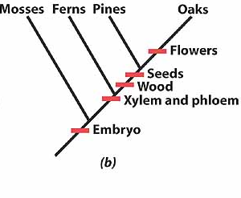

Cladogram #2
22. What animals does not have jaws?
________________________________________
23. Which animals have lungs?
________________________________________________________________________________
24. Which of the following groups, taken by themselves, do NOT form a clade?
a. Pidgeon, Mouse and Chimp
b. Lizard, Pigeon and Mouse
c. Salamander, Lizard, Pigeon, Mouse and Chimp
d. Hagfish, Perch, Salamander, Lizard, Pigeon, Mouse and Chimp

- What is a Cladogram? What does it show?______________________________________________
_____________________________________________________________________________________
- Fill in the following chart:
Kingdom | Prokaryotic/  Eukaryotic | Multicellular/  Unicellular or BOTH | Autotroph/  Heterotroph or BOTH | Examples
Archaeabacteria (ancient bacteria)

Bacteria

Protista

Fungi

Plantae
(plants)

Animalia
(animals)

