Name:________________________________ Date:________________________ Period:____________

Unit 8: Classification

1. Why do biologists classify organisms?__________________________________________________

_________________________________________________________________________________

1. What is the classification of living things known as?________________________________________
2. What is binomial nomenclature & how is it written?________________________________________

______________________________________________________________________________________

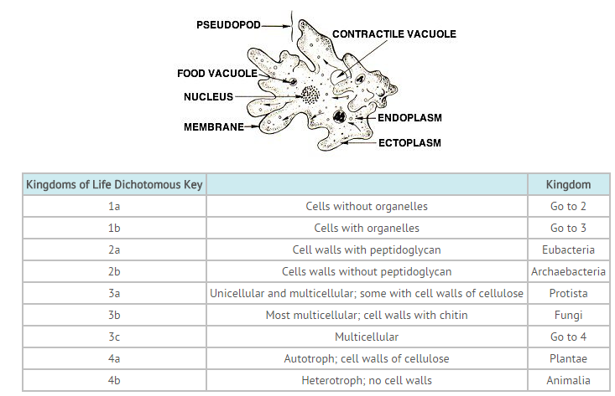

4. According to the dichotomous key, the amoeba seen in the illustration would belong in the kingdom ________.

_____________________________________

1. What is a taxon?____________________________________________________________________
2. Which taxon includes the most organisms?_____________________________________________
3. List the taxa in order from broadest to most specific.___________________________________________________

________________________________________________________________________________________________________________________________________________________________________________________________

1. What is a kingdom made up of?________________________________________________________
2. What is a phylum made up of?_________________________________________________________
3. What is a class made up of?___________________________________________________________
4. What is an order made up of?_________________________________________________________
5. What is a family made up of?___________________________________________________________
6. What is a genus made up of?___________________________________________________________
7. What is a species made up of?__________________________________________________________
8. What are the 3 domains of life and which kingdoms are included in each?_______________________

__________________________________________________________________________________________________________________________________________________________________________________________________

1. Fill in the following chart:

|  |  |  |  |  |
| --- | --- | --- | --- | --- |
| Kingdom | Prokaryotic/Eukaryotic | Multicellular/ Unicellular or BOTH | Autotroph/ Heterotroph or BOTH | Examples |
| Archaeabacteria (ancient bacteria) |  |  |  |  |
| Bacteria |  |  |  |  |
| Protista |  |  |  |  |
| Fungi |  |  |  |  |
| Plantae  (plants) |  |  |  |  |
| Animalia  (animals) |  |  |  |  |

1. What is the difference between Eubacteria and Archaebacteria?___________________________

____________________________________________________________________________________________________________________________________________________________________________

1. Draw and label a bacterial cell.
2. What are the 3 shapes of bacteria? Draw each type and label accordingly.
3. What are pathogens?_______________________________________________________________
4. What are the cell walls of fungus made of? Plants?______________________________________

______________________________________________________________________________________

1. What organelles does a plant cell have that an animal cell does not?_________________________

______________________________________________________________________________________

1. Draw and label a flower with the following: pistil, ovary, anther, & filament. Color female parts pink and male parts blue.
2. What is a tropism?__________________________________________________________________

___________________________________________________________________________________

1. Complete the picture by drawing a flower that exhibits phototropism.

1. What is gravitropism?______________________________________________________________

________________________________________________________________________________

1. Describe the functions of the following parts of the plant:
   1. Xylem-_____________________________________________
   2. Phloem-____________________________________________
   3. Stomata-____________________________________________
2. Describe the distinguishing characteristics that led to the evolution of the following groups of plants:
   1. Bryophytes (moss):_________________________________________________________________
   2. Pteridophytes (ferns):_______________________________________________________________
   3. Gymnosperms (pine trees):___________________________________________________________
   4. Angiosperims (flowering plants):______________________________________________________
3. Similar genes (DNA & RNA) are evidence of what?_______________________________________

______________________________________________________________________________________

1. What is a Cladogram? What does it show?______________________________________________

______________________________________________________________________________________

1. How is a Cladogram structured? (Describe)_____________________________________________

________________________________________________________________________________

32. Which 2 organisms would be most **closely** related? How do you know?______________

____________________________________________________________________________________________________________________________________________________

_____________________________________

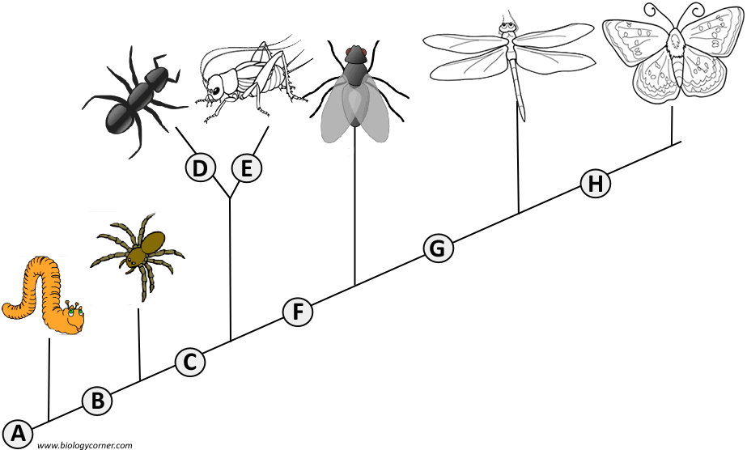

1. What is the difference between ancestral and derived traits?_______________________________

______________________________________________________________________________________

1. Draw and label a virus. Include the protein coat/viral capsid, and nucleic acids.
2. Draw a Venn Diagram that compares viruses and living bacterial cells.
3. What is the function of a viral capsid (protein coat)?____________________________________________

______________________________________________________________________________________

1. Describe the difference between the Lytic cycle and lysogenic cycle of viruses. ________________

______________________________________________________________________________________

1. Which letter indicates the stage at which…

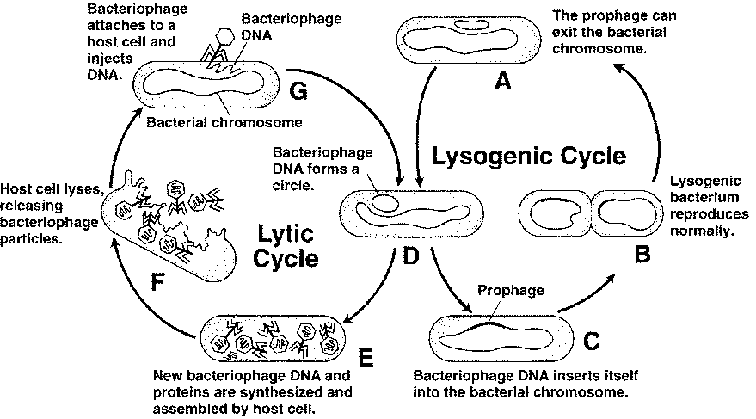

* 1. a bacteriophage injects DNA into a host cell? _______
  2. a host cell begins producing new bacteriophage? _______
  3. the bacteriophage DNA becomes part of the host cell’s DNA? ______
  4. In which cycle is the host cell destroyed? _______

1. What are examples of diseases caused by viruses?_______________________________________________

___________________________________________________________________________________________