Name:_________________________________ Date:______________________ Period:___________

Unit 4: Cell Division Study Guide

- NUMBER the stages of the cell cycle in order from 1→6 in the spaces below.
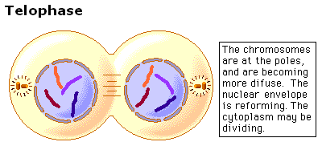
___________ __________ _________ _________ _________ __________
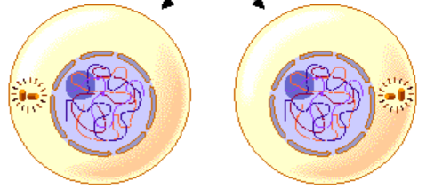

_______________ _______________ ______________ ________________ ______________ __________________
_______________ _______________ ______________ ________________ ______________ __________________
- LABEL the names of the phases of mitosis in the spaces above. Include the key word for each stage below the name.
- What occurs in Interphase?___________________________________________________________
________________________________________________________________________________________
- What is mitosis? How many daughter cells are produced? What type of cells?___________________
__________________________________________________________________________________
- What are the 4 steps of Mitosis? List and describe the 4 steps of Mitosis.
_______________________________-__________________________________________________
_______________________________-__________________________________________________
_______________________________-__________________________________________________
_______________________________-__________________________________________________
- What is cytokinesis?_________________________________________________________________
- Draw sister chromatids/homologous chromosomes. Label the centromere, chromatids, & sister chromatids.

- What do sister chromatids represent?__________________________________________________
- What are spindle fibers and what do they do in cell division?________________________________
_________________________________________________________________________________
- What organelle involved in mitosis is only found in animal cells?_____________________________
- What is the difference between a plant and animal cell in regards to cytokinesis?________________
__________________________________________________________________________________
- List the 3 phases of interphase and describe what occurs in each.
_____________________________-____________________________________________________
_____________________________-____________________________________________________
_____________________________-____________________________________________________
- In mitosis, how are the daughter and the parent cells related regarding their chromosome numbers?
__________________________________________________________________________________
- Why is mitosis important to multicellular organisms?_______________________________________
__________________________________________________________________________________

- What kind of traits do homologous chromosomes/sister chromatids code for, SAME or DIFFERENT?
__________________________________________________________________________________
- How many chromosomes are in an adult organism? Haploid or Diploid?________________________
__________________________________________________________________________________
- How many chromosomes are in a gamete? Haploid or Diploid?_______________________________
- Where does meiosis happen in females and males?________________________________________
- How many egg cells produced by meiosis can actually be used for fertilization? Explain why. __________________________________________________________________________________
- Sketch and color the chromosome displaying crossing over between C and D segments on the sister chromatids.

- In meiosis, how are the daughter and the parent cells related regarding their chromosome numbers?_________________________________________________________________________
- What is fertilization? Draw a picture of it on the cellular level.________________________________
__________________________________________________________________________________

- What is fertilized egg cell called?__________________________________
- What is crossing over? What is its purpose? When does it occur?_____________________________
____________________________________________________________________________________________________________________________________________________________________
- What is meiosis? How many daughter cells are produced? What type of cells?__________________
_______________________________________________________________________________________
- NUMBER the stages of meiosis in order from 1→8 in the spaces below.
_________ __________ _________ _________ _______ ________ _______ ___________
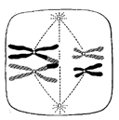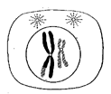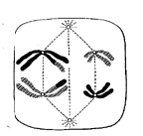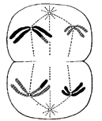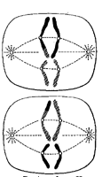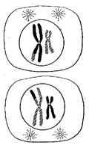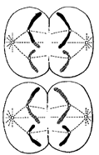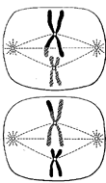
_____________ _____________ ___________ ____________ ___________ ___________ __________ ____________
- LABEL the phases of meiosis in the spaces above. Include cell division I or II.
- What is the difference between haploid and diploid?_______________________________________
__________________________________________________________________________________
- What is cancer? What causes it? What does it do to normal cells?____________________________
____________________________________________________________________________________________________________________________________________________________________

- Sketch a graph showing a normal cell’s growth versus a cancerous cell’s growth.

- What is a stem cell? How is it useful in medicine?__________________________________________
__________________________________________________________________________________
- What is the process in which bacteria/prokaryotes reproduce? Describe the shape of their DNA.____
____________________________________________________________________________________________________________________________________________________________________
- What is the goal of sexual reproduction?_________________________________________________
__________________________________________________________________________________
- Compare and contrast Asexual reproduction (mitosis & binary fission) with Sexual reproduction (meiosis) using a Venn diagram. Include the advantages and disadvantages of each process.

