Biome Brochure Project
You have been assigned a biome to research with your group. (Students who are absent on in-class work days must perform all of the research on their own). You may not change groups or research a different biome. Projects must be presented on the due date, regardless of who is absent from the group. Late point deductions will be given to any group not prepared to present on the day that the project is due.
Purpose: Inform others about your biome and encourage them to choose your biome as their #1 travel destination.
Product: Your group will produce an informative travel brochure. This can be done using Microsoft Publisher, or any other electronic medium that creates a brochure format.
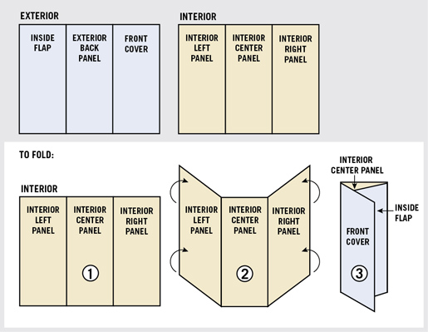
The Details:

Your brochure must include:
- Title Page (Right column, the one that folds to the front)
  - Name of your biome
  - Picture of your biome
  - Class block
  - Names of all participating group members
- Page#1 – Left Column (inside)
  - Map of the world with your biome highlighted
  - Flora: 5 or more plants in this biome. For 2 of the plants, give pictures and adaptations they have that suit them well to this biome and climate.

- Page #2 – Center column (inside)
  - Climate of your biome (average daily temperature, a chart or graph of seasonal temperatures throughout the year, what seasons your biome has, chart or graph of seasonal precipitation of your biome)
  - Guide for how travelers: Best time of year to visit and how they should dress when visiting your biome during this time
- Page #3 – Right column (inside)
  - Fauna: 5 or more animals in this biome. For 2 of the animals, give pictures and adaptations they have that suit them well to this biome and climate.
  - Food Web for an organism at the highest trophic level in this biome OR Food pyramid showing examples of organisms that are producers, primary consumers, secondary consumers, and tertiary consumers (if applicable) Must be made by you – not downloaded/copy-pasted.
- Page #4 – Left column (outside, the one that folds underneath the title page)
  - 5 or more threats to your biome, with some details about each threat (be sure to include natural as well as human-induced threats). 1 picture related to one of the threats.
- Page #5 – Center column (back of brochure)
  - Traveler’s Guide
    - Public parks or lands to visit in your biome
    - Top 5 reasons to visit your biome
    - Interesting pictures related to any of the parks or top 5 reasons
  - Citations
    - Note the website titles or book titles of any resources that you used. (Not official APA or MLA citations – just something that the traveler could access to find out more about this biome).
Brochures should contain correct grammar and spelling. Graphs of temperature and rainfall can be inserted from a reputable weather source, provided you include that site in your citations list on the back. You may use both your textbook and any credible scientific Internet sources (not Wikipedia) to find your information.
Suggested sites: Cobb Virtual Library Science in Context,
Thewildclassroom.com
http://www.ucmp.berkeley.edu/glossary/gloss5/biome/
https://earthobservatory.nasa.gov/Experiments/Biome/
http://www.blueplanetbiomes.org/world_biomes.htm

Biomes Brochure Rubric
DESCRIPTION | 5 POINTS | 4.5 POINTS | 4 POINTS | 3.5 POINTS
Cover/Front Page | Contains your names, biome name, and a picture | Contains only 2 of the required items | Contains only one of the required information | N/A
Page #1  Left Column Inside | Contains five or more plants, gave adaptations, and two pictures with captions, along with map of the world. | Missing one of the items. | Missing 2 items | Missing 3 items
Page #2  Center Column | Contains the average temperature, a temperature graph, the seasons experienced in the biome, and a precipitation graph. | Missing one of the items | Missing 2 of the items | Missing 3 items
Page #3  Right Column Inside | Contains five or more animals, gave adaptations, and two pictures. Gives food web or pyramid. | Missing 1 item. Food web may be incomplete. | May be missing 2 of the items | Missing 3 items
Page #4  Left Column Outside | Contains five biome threats, gave some details of each threat, and one picture with captions | Missing 1 threat or 1 detail | Missing 2 threats or details | Missing 3 threats or details
Page #5  Center Column Outside | Lists some public parks or lands to visit, gives 5 reasons to visit, and includes a relevant picture. Contains citations. | Missing 1 of the items | Missing 2 items | Missing 3 items
Grammar and Readability | Contains no spelling or grammatical errors; is easy to read/see. | Contains a few spelling or grammatical errors, may be a little difficult to read. | Contains some spelling/grammar errors; difficult to read | Barely readable (font color or size) and with several spelling/grammar errors.
Use of class time | Was focused and used every opportunity to better project. Never caught off-task. | Was focused and used most class time. Caught off-task only 1-2 times. | Caught off-task 3-4 times. | Was rarely focused and wasted time continuously. Off-task 5+ times.
DESCRIPTION | 10 POINTS | 9 POINTS | 8 POINTS | 7 POINTS
Presentation | Spoke clearly and loudly enough for all to hear, while making eye contact. Knowledgeable of all parts of the project (did not have to read from brochure or delegate to groupmate). | Spoke clearly, while making eye contact. Knowledgeable of most parts of the project. | Spoke audibly, with occasional eye contact. Knowledgeable of one part of the project. | Difficult to hear what was said. Not very knowledgeable of any part of the project.

