Analyzing the Demographics of a Country

Population pyramids are a good way to get a breakdown of a country’s demographics based on age and gender. These demographics can then be used to determine what stage of the demographic transition a country is in. All data will be collected at the U.S. Census website:

census.gov/population/international/data/idb/informationGateway.php

Part I – Background

Shade in and label the country you are researching on the map below.

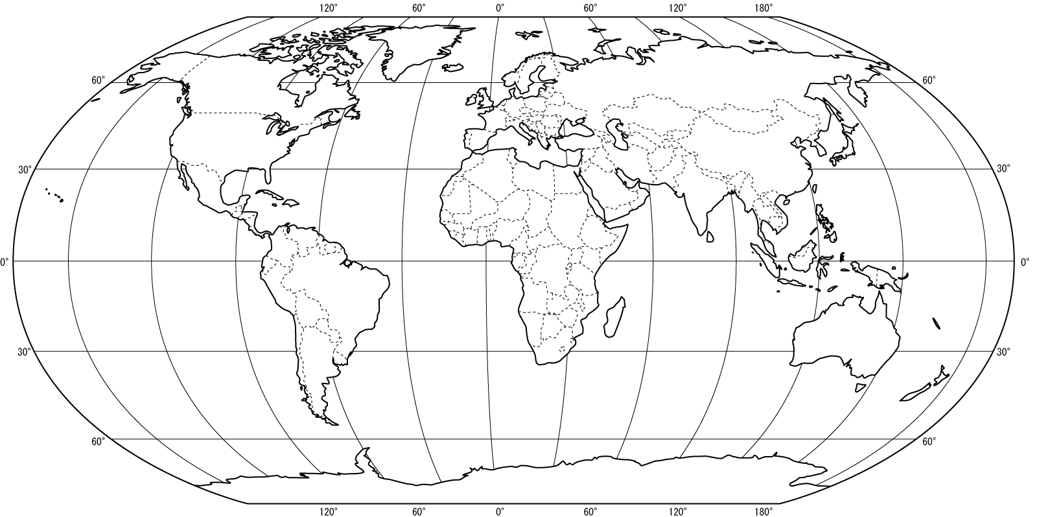

- In Google, type in “gross domestic product per capita” and your country’s name. Record the GDP per capita below. Do the same for the United States, India, and Kenya.

 | United States | India | Kenya
GDP Per Capita (In Dollars)

- What exactly does GDP per capita mean?

- Based on this number, would you classify your country as developed or developing?

Part II – Population Growth Rate

- Choose the “Demographic Overview” report from the pull-down menu.

- Select 1980, 1985, 1990, 1995, 2000, 2005, 2010, and the current year.

- Fill in the table below.

 | 1980 | 1985 | 1990 | 1995 | 2000 | 2005 | 2010
Midyear Population
(In Thousands)
Growth Rate
(Percent)

- Would you describe the population of your country since 1980 to be growing rapidly, growing slowly, stable, or shrinking?

- Doubling time is an estimation of how long it will take the country to double in size, given its current growth rate. It is calculated with the following formula:
Doubling Time = 70 / % Growth Rate
What is the doubling time of your country?

Part II – Total Fertility Rate

One of the most important factors in determining a country’s demographic status is the average number of children a woman will have in her lifetime, also called the total fertility rate.
- Choose the “Fertility
Rates” report from the
pull-down menu.

- Select 1980, 1985, 1990,
1995, 2000, 2005, 2010,
and the current year.

- Graph the change in
fertility rate since 1980.

- Is the total fertility rate of your country increasing or decreasing?

- What might have made the total fertility rate higher in some years?

- What might explain any decrease in total fertility rate?

Part III – Population Pyramid

Population pyramids are a good way to get a breakdown of a country’s demographics based on age and gender. These demographics can then be used to determine what stage of the demographic transition a country is in.

- Make sure “Population by Five Year Age Groups” is selected at the top.
- Select your country of interest.
- Select the most recent year.
- Choose the button for “show individual country data only” At the bottom of the page.
- Click “submit”.

Create a population pyramid based on the template below.
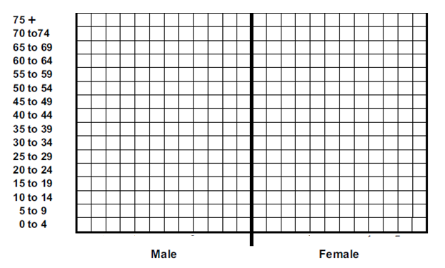

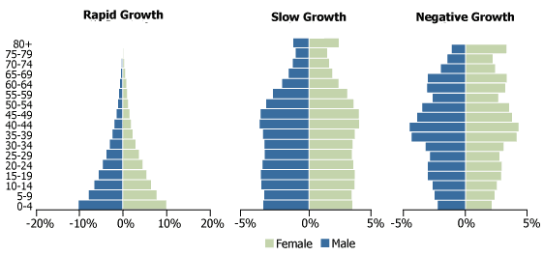

- Compare the shape of your graph to the examples on above. Is your country a rapid growth, slow growth, or negative growth country?

- Are there any dominant age groups? (Children, young adults, middle aged, elderly)

- Approximately what percentage of the population survives into the 60-64 age group?

- Are the male and female sides roughly equal or is there a significant difference?

Part IV – Demographic Transition

Label each stage of the demographic transition below, starting with preindustrial, early transition, late transition, industrial, and ending with postindustrial. Mark on the graph where you think your country would be, based on the data you collected.

