Name_________________________________ Date__________________________________
Water Treatment WebQuest
SAFE DRINKING WATER! How do we get it? What process does water go through to become safe enough to drink? Explore the following websites to find out. Use this diagram to help you learn about this process.
Use the following link to complete this section of the activity.
https://www.cdc.gov/healthywater/drinking/public/water_treatment.html
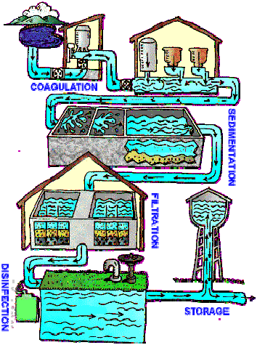
Water enters the treatment plant from a river, reservoir or well and is first screened to remove leaves, twigs and other large objects.

- Write 2-3 statements describing what happens in the next steps of the water treatment.

Coagulation: ________________________________
___________________________________________
___________________________________________
___________________________________________
___________________________________________
___________________________________________
___________________________________________
___________________________________________

Sedimentation: ______________________________
___________________________________________
___________________________________________
___________________________________________
___________________________________________
___________________________________________
___________________________________________

Filtration: ___________________________________
___________________________________________
_____________________________________________________________________________________________
_____________________________________________________________________________________________
_____________________________________________________________________________________________
Disinfection: _________________________________________________________________________________
_____________________________________________________________________________________________
_____________________________________________________________________________________________
_____________________________________________________________________________________________
(Sometimes other treatments such as fluoridation or pH adjustment may occur at the end of this stage.)
Storage:_____________________________________________________________________________________
_____________________________________________________________________________________________
___________________________ (After storage, water travels via pipelines to homes and businesses.)
Go to https://www.cityofpowdersprings.org/681/Water and read about Powder Springs’ Water Treatment Plant.
- What 2 bodies of water are used to supply our drinking water?____________________________________ ______________________________________________________________________________________

Click on “Water Quality Reports” to open up the water report for 2017 to answer the following questions. Read “How is my water treated?” section to summarize the process below.
- ________________________________________________________________________________________________________________________________________________________________________________
________________________________________________________________________________________________________________________________________________________________________________
- Define flocculation-________________________________________________________________________
- Define filtration-___________________________________________________________________________
Read “Why are these contaminants?” section to identify examples and describe the types of the contaminants.
- _______________________-____________________________________________________________
_______________________-____________________________________________________________
_______________________-____________________________________________________________
_______________________-____________________________________________________________
_______________________-____________________________________________________________
Read the “Drinking Water Analysis Table” section to identify the sources of the following contaminants.
- Fluoride-____________________________________________________________________________
Copper-_____________________________________________________________________________
Lead-_______________________________________________________________________________
Nitrates-____________________________________________________________________________
Chlorine-____________________________________________________________________________
- Do you believe there is a way to prevent these contaminants from being present in our water? Give a valid explanation to support your answer._____________________________________________________________
________________________________________________________________________________________________________________________________________________________________________________________________________________________________________________________________________________________________________________________________________________________________________
Click on “Water Conservation” and describe 4 ways the YOU can help conserve water.
- ________________________________________________________________________________________
______________________________________________________________________________________________________________________________________________________________________________________________________________________________________________________________________________
Click on http://www.cityofpowdersprings.org/631/Rates-Fees to answer the following.

- What would it cost a Powder Springs resident to purchase 5,000 gallons of clean water? (Show work….)
___________________________________________________________________________________________

- Does that seem expensive to you? ____________ Why or why not? ________________________________
___________________________________________________________________________________________

At this point in your WebQuest, you have not learned about sewage treatment (the process that cleans wastewater back to ‘useable’ water). However, since you are on the Powder Springs rates page, look at the rates charged by the city to take wastewater (any water that goes down the drain or toilet) away from a home or business. Look in the Sewer Tiers section.
- What would it cost a Powder Springs resident to get rid of 5000 gallons of ‘used’ water (sewage)? (Show work!)
___________________________________________________________________________________________

- If you did your math correctly, you will see that it costs more to get rid of dirty water than it does to get clean water. What do you think about this fact? ______________________________________________________________________________________________________________________________________________________________________________

Go to http://www.epa.gov/safewater/kids/flash/flash_qagame.html for a fun review.

- Record the number of questions you got correct here: _____________ Have someone look at your computer screen to verify that this is correct and sign off: _________________________

Now that you know how water is made safe to drink, what happens to water that goes down the drain or toilet? Follow the path the WebQuest takes you to discover the answer!
Go to https://water.usgs.gov/edu/wuww.html
Read what wastewater is and why we treat it.

- Wastewater is ____________________________________________________________________________
_____________________________________________________________________________________________
- What are some reasons why we treat wastewater?
- _____________________________________________________________________________
- _____________________________________________________________________________
- _____________________________________________________________________________
- _____________________________________________________________________________

Click on the following link (using internet explorer!) and click on “Start Tour” to learn about the steps of wastewater treatment and summarize those steps next to each image below.
Go to: https://www.gbra.org/wastewater-treatment.swf
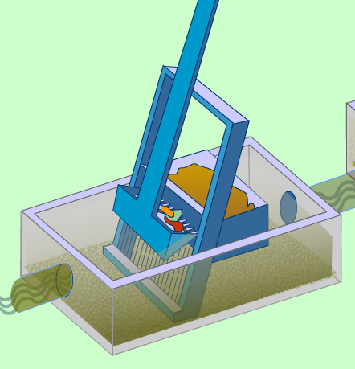
- ____________________________________________________________________________________________________________________________________________________________________________________________________________________________________________________________________________________________________________________________________________________
________________________________________________________________________

- _____________________________________________________________________________________________________________________________________________________________________________________________________________________

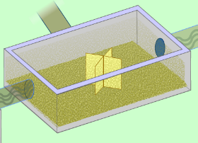

- ________________________________________________________________________________________________________________________________________________________________________________________________________________________________________________________________________________________________________________________________________________________________________
________________________________________________________________________________________________________________________________________________

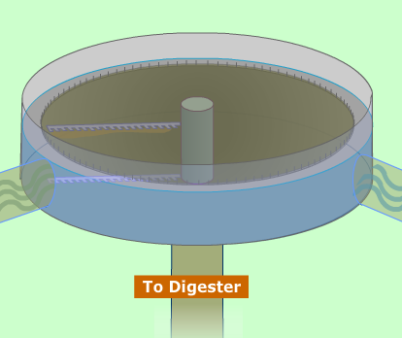
- ________________________________________________________________________________________________________________________________________________________________________________________________________________________
________________________________________________________________________
________________________________________________________________________
________________________________________________________________________________________________________________________________________________________________________________________________________________________________________________________________________________________________How are microorganisms used in this process?___________________________________
________________________________________________________________________________________________________________________________________________
________________________________________________________________________

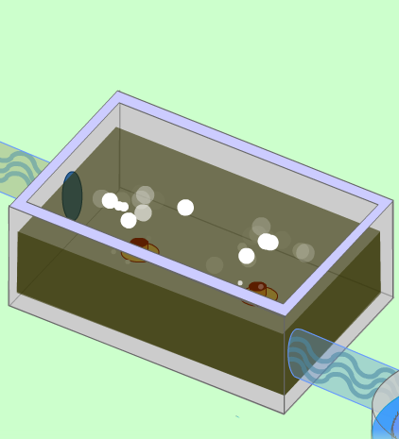
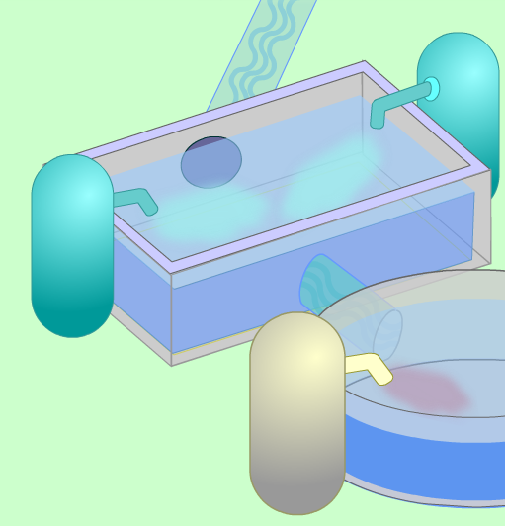
- _____________________________________________________________________________________________________________________________________________________________________________________________________________________
____________________________________________________________________________________________________________________________________________________________________________________________________________________________________________________________________________________________
_____________________________________________________________________________________________________________________________________________________________________________________________________________________

- How is UV light used to disinfect water?________________________________________________________
___________________________________________________________________________________________
- Describe the 3 forms of tertiary treatment of water below.
A. Chemical-______________________________________________________________________________
B. Physical-_______________________________________________________________________________
C. Biological-______________________________________________________________________________
- What is the difference between influent and effluent water?_______________________________________
________________________________________________________________________________________
- What can effluent water be used for?__________________________________________________________

- What has surprised you the most about what you have found out today? SUMMARIZE what you have learned in a 3-4 COMPLETE sentence paragraph!___________________ _____________________________
_____________________________________________________________________________________________
_____________________________________________________________________________________________
_________________________________________________________________________________________________________________________________________________________________________________________________________________________________________________________________________________________________________________________________________________________________________________________________________________________________________________________________________________
__________________________________________________________________________________________________________________________________________________________________________________________
- Is there something you still want to know and haven’t found out yet? ______________ If so, what is it?
___________________________________________________________________________________________
__________________________________________________________________________________________________________________________________________________________________________________________

I hope you enjoyed learning about how we get clean (potable) water and what happens to all that wastewater that leaves our homes. Remember, the water we use today is the same water used by people thousands of years ago and we must keep it clean for the people of the future!

