Study Guide Unit 6: Molecular Genetics Chapter 8 From DNA to Proteins
Chapter 9 Frontiers of Biotechnology
SB2. Obtain, evaluate, and communicate information to analyze how genetic information is expressed in cells.

a. Construct an explanation of how the structures of DNA and RNA lead to the expression of information within the cell via the processes of replication, transcription, and translation.

b. Construct an argument based on evidence to support the claim that inheritable genetic variations may result from:
- non-lethal errors occurring during replication (insertions, deletions, substitutions); and/or
- heritable mutations caused by environmental factors (radiation, chemicals, and viruses).

c. Ask questions to gather and communicate information about the use and ethical considerations of biotechnology in forensics, medicine, and agriculture.
- List the 3 parts of a nucleotide.

- Label A and B on the DNA double helix below:
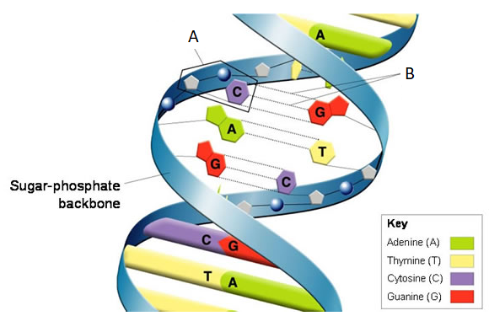
- Where is DNA located in a cell?

- What are the base pairing rules for DNA?

- If a cell DNA contains 30% Adenine, what percentage of the cells DNA will be Guanine, Cytosine, and Thymine?

- What are the base pairing rules for RNA?

- What are 3 ways DNA and RNA are different?

- List each type of RNA and describe their functions.

- Arrange in order from largest to smallest the following: chromosome, nucleus, cell, DNA, nucleotide.

- What is DNA replication?

- What is transcription? What is produced? Where does it take place?

- What is translation? What is produced? Where does it take place?

- What do genes assemble?

- Draw DNA replication with the parent strand in one color and the new strand in another color.

- Why is it possible for an amino acid to be coded for by more than one codon sequence?

- If 3 bases equals 1 codon, how many bases equals 4 codons? _____

- If 1 codon equals 1 amino acid, how many codons equals 6 amino acids? _____

- How many bases would equal 3 amino acids? ______

- Transcribe and translate the following DNA sequence. AAG TTC CGG TAA TGC CCC

- What is an intron? What is an exon? Which one becomes expressed?

- In DNA replication, which enzyme unzips the DNA?

- In DNA replication, which enzyme removes the RNA primer and replaces it with new bases?

- What are codons? Where are they located?

- What are anti-codons? Where are they located?

- Label A-F on the picture below:
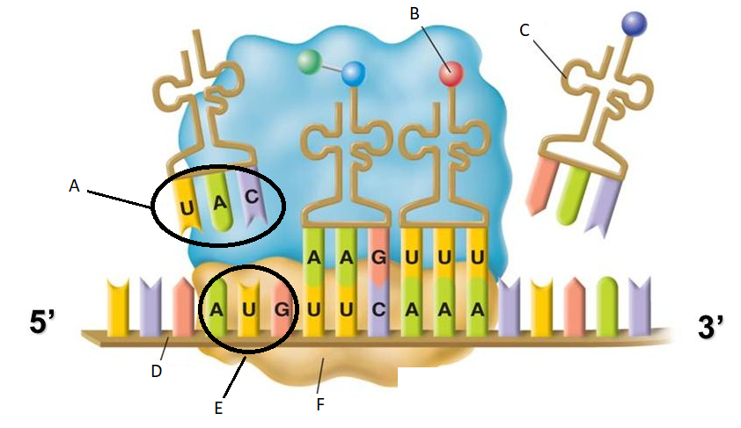
- What is a mutation?

- What can cause mutations?

- Where can mutations occur?

- List the 3 types of point mutations and describe what happens in each.

- Describe silent, missense, and nonsense mutations.

- What is a frameshift mutation? What affect does it have on the rest of the amino acid sequence?

- List the types of chromosomal mutations and describe what happens in each.

- Which is worse? (Circle one for each scenario)
- A mutation in mitosis or meiosis
- A mutation in transcription or translation
- A mutation at the beginning of a gene or at the end of a gene
- A substitution or a deletion
- A somatic/autosome cell or a gamete/sex cell
- An intron or an exon
- Define genetic engineering.

- What is a genome?

- What is recombinant DNA?

- What is a transgenic organism?

- What is a clone?

- What is transformation?

- What is a restriction enzyme?

- Which restriction enzyme cuts at GAATTC? (Remember: DNA fragments cut by a restriction enzyme can pair up and join with any other DNA fragments cut by the same restriction enzyme)

- What is gel electrophoresis? How can you determine a genetic match using this technique?

- What charge is DNA? Why does it move towards the positive end on the gel electrophoresis?

- Use image below: Which bands are smaller A or B? Explain why.
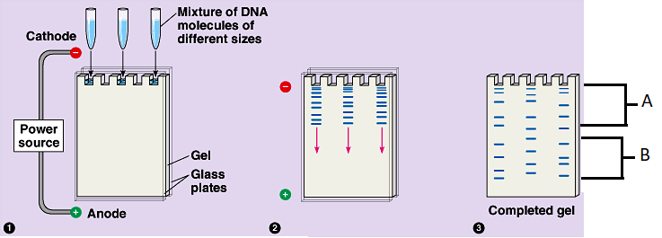
- How can gel electrophoresis/DNA fingerprinting be used in forensics?

- What is gene therapy? Why do they use viruses for it?

- Explain the process of cloning.

My protein synthesis quiz is on ___________________________________

My mutations quiz is on ____________________________________________

My Unit 5 Molecular Genetics test is on ___________________________________

What should I use to study for my test?
- Powerpoint notes
- This study guide
- Handouts given in class
- My quiz

