Unit 5: Mendelian Genetics Chapter 6.3: Mendel and Heredity
Study Guide Chapter 6.4 Traits, Genes and Alleles
What Do I Need To Know? Chapter 6.5 Traits and Probability
Chapter 7 Extending Mendelian Genetics
SB3. Obtain, evaluate, and communicate information to analyze how biological traits are passed on to successive generations.

a. Use Mendel’s laws (segregation and independent assortment) to ask questions and define problems that explain the role of meiosis in reproductive variability.

b. Use mathematical models to predict and explain patterns of inheritance.
- Where is DNA located in a cell?

- What does DNA contain?

- What is a karyotype? What can it show?

- What is nondisjunction?

- How many chromosomes does a normal human have?

- What is Tay Sach’s? What type of disorder is it?

- What is Cystic fibrosis? What type of disorder is it?

- What is color-blindness? What type of disorder is it?

- What is Hemophilia? What type of disorder is it?

- What is Albinism? What type of disorder is it?

- What is Sickle-Cell Anemia? What type of disorder is it?

- What is Huntington’s disease? What type of disorder is it?

- What is Klinefelter's Syndrome? What type of disorder is it?

- What is Turner’s syndrome? What type of disorder is it?

- What is Down’s Syndrome/Trisomy 21? What type of disorder is it?

- How many chromosomes does someone with Down’s syndrome or Klinefelter's have?

- How many chromosomes does someone with Turner’s syndrome have?

- What is a genotype?

- What is a phenotype?

- Dominant/Recessive Cross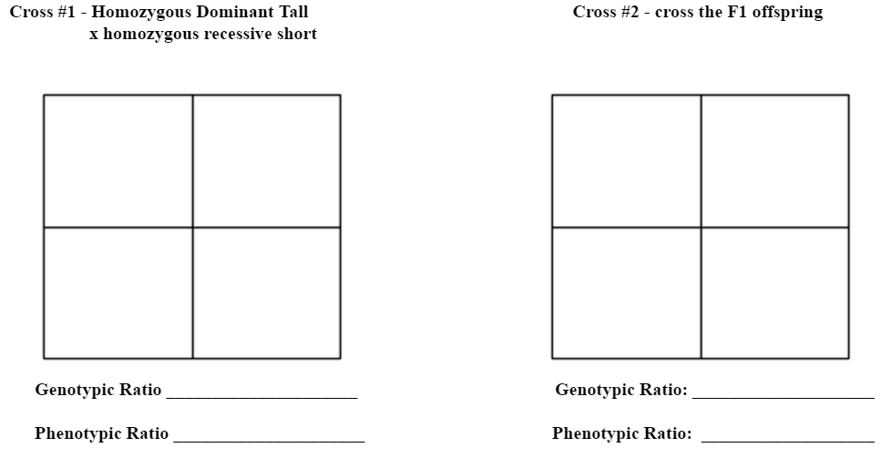
- What is incomplete dominance?

- Incomplete Dominance Cross
- What does P stand for? F₁? F₂?

- What is the Law of Segregation?

- What is the Law of Independent Assortment?

- Write an example of heterozygous using any letter you want.

- Write an example of homozygous dominant using any letter you want.

- Write an example of homozygous recessive using any letter you want.

- What is another term for homozygous?

- What is another term for heterozygous?

- Fill-in-the-blank: Sex-Linked traits show up more in ______________, because they happen on the _________ chromosome.

- List 2 examples of Sex-Linked conditions.

- What is controlled by multiple alleles?

- Write the possible genotypes for the following blood types:
  - A=
  - B=
  - AB=
  - O=
- Do Mendel’s principles of heredity apply to plants, animals, pea plants, or all living organisms?

- What does a pedigree show?

- Pedigree Chart

- Draw a pedigree with a mom carrier for hemophilia and a normal dad.
They have 2 carrier daughters, 2 normal daughters, and 2 affected sons.

- Multiple Allele Cross (Blood Types)

- Perform a cross between an individual who is heterozygous for eye color and someone who is homozygous recessive. Brown eyes are dominant to blue eyes. Give the genotypic & phenotypic percentages.

- Perform a cross for height in pea plants. Cross 2 heterozygous pea plants. Tall is dominant to short. Give the genotypic and phenotypic percentages.

- Perform a cross for hair color between a homozygous dominant person and a homozygous recessive person. Brown is dominant to blonde. Give the genotypic & phenotypic ratios.

- Perform a cross between a Blue flower and a yellow flower using Codominance. Show a second generation. Give the genotypic & phenotypic ratios.

- Perform a cross between a heterozygous brown-eyed woman and a heterozygous brown-eyed male. Give the genotypic & phenotypic ratios.

- Perform a cross between a woman who is colorblind and a normal male. Give the genotypic & phenotypic ratios.

- Perform a cross between a male with hemophilia and a carrier mother. Give the genotypic & phenotypic ratios.

My genetics quiz is on ____________________________________
My Unit 4 Mendelian Genetics test is on ______________________________
What should I use to study for my test?

- Powerpoint notes
- This study guide
- Handouts given in class
- My quiz

