Name:________________________________ Date:________________________ Period:____________
Unit 6: Molecular Genetics Study Guide
- Draw and label the 3 parts of a nucleotide.

- Where is DNA located in a cell?____________________________________________________________
- What are the base pairing rules for DNA?____________________________________________________
- If a cell DNA contains 30% Adenine, what percentage of the cells DNA will be Guanine, Cytosine, and Thymine?___________________________________________________
- Compare the DNA of prokaryotes to the DNA in eukaryotes._____________________________________
______________________________________________________________________________________
- What is DNA replication? Describe the end products of DNA replication.___________________________ ______________________________________________________________________________________
______________________________________________________________________________________
- What are the functions of DNA polymerase and DNA helicase?___________________________________ ______________________________________________________________________________________
- Draw DNA replication with the parent strand in one color and the new strand in another color.

- What are the base pairing rules for RNA?___________________________________________________
- Compare and contrast DNA vs. RNA below.

- Name and describe the 2 steps of Protein Synthesis. Where does each step take place?
Steps of protein synthesis | Description of steps | Molecules  needed | Area in cell where process occurs
- Label A-F on the picture below:
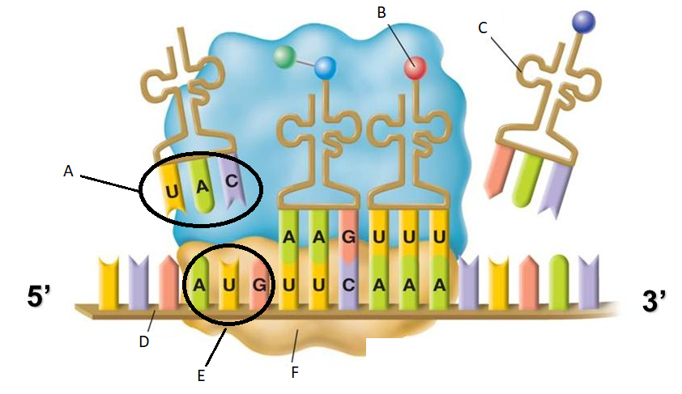
- What is another word for protein? Why is it called this?_________________________________________
______________________________________________________________________________________
- Describe the functions of the following molecules:
  - amino acids- _______________________________________________________
  - mRNA-____________________________________________________________
  - tRNA-_____________________________________________________________
  - rRNA-_____________________________________________________________
Read the following codon chart to translate this mRNA strand: UCUGGCACGAAG
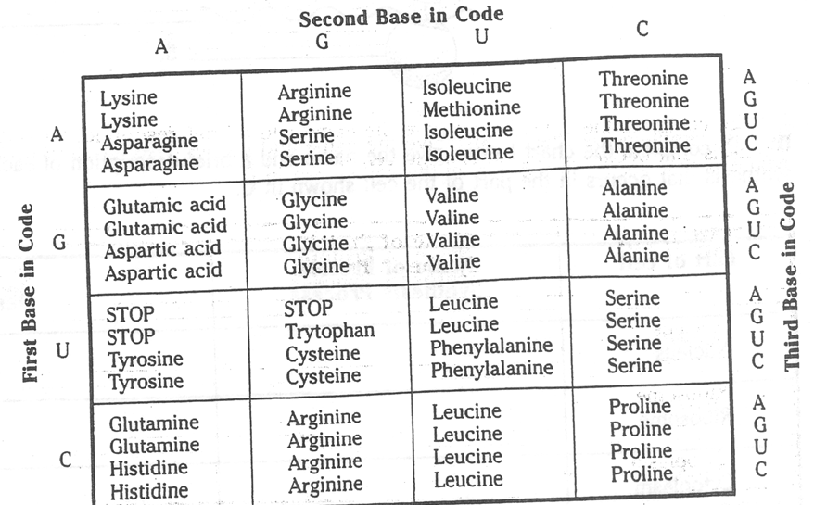
15. Write the sequence for the DNA.
_________________________________________
16. Write the anticodons for the mRNA strand.
_________________________________________
17. Write the amino acid sequence.
_________________________________________
- Why is it possible for an amino acid to be coded for by more than one codon sequence?_______________
______________________________________________________________________________________
- If 3 bases equals 1 codon, how many bases equals 4 codons? _____
- If 1 codon equals 1 amino acid, how many codons equals 6 amino acids? _____
- How many bases would equal 3 amino acids? ______

- Transcribe and translate the following DNA sequence. AAG TTC CGG TAA TGC CCC
mRNA______________________________________________________________________________
tRNA_______________________________________________________________________________
amino acid sequence__________________________________________________________________
- What are codons? Where are they located?___________________________________________________
______________________________________________________________________________________
- What are anti-codons? Where are they located?_______________________________________________
______________________________________________________________________________________
- What is a mutation?______________________________________________________________________
______________________________________________________________________________________
- What can cause mutations?_______________________________________________________________
______________________________________________________________________________________
- What is a point mutation?________________________________________________________________
- List the 3 types of point mutations and describe what happens in each.
___________________________-__________________________________________________________
___________________________-__________________________________________________________
___________________________-__________________________________________________________
- What is a frameshift mutation? What affect does it have on the rest of the amino acid sequence?
______________________________________________________________________________________
- Name and describe the 2 types of frameshift mutations.
___________________________-__________________________________________________________
___________________________-__________________________________________________________
- List the 3 types of chromosomal mutations and describe what happens in each.
___________________________-__________________________________________________________
___________________________-__________________________________________________________
___________________________-__________________________________________________________
- Which is worse? (Circle one for each scenario)
  - A mutation in mitosis or meiosis
  - A mutation at the beginning of a gene or at the end of a gene
  - A substitution or a deletion
  - A somatic/autosome cell or a gamete/sex cell
- Define genetic engineering.________________________________________________________________
______________________________________________________________________________________
- Describe some ways genetic engineering has been used in the medical field.
____________________________________________________________________________________________________________________________________________________________________________
- What is a transgenic organism? Give an example. ______________________________________________
______________________________________________________________________________________
- What is a clone?_________________________________________________________________________
______________________________________________________________________________________

- Describe the process of cloning. Which organisms does the clone look identical to?___________________
____________________________________________________________________________________________________________________________________________________________________________
- What is a restriction enzyme?______________________________________________________________
- Which restriction enzyme cuts at GAATTC? (Remember: DNA fragments cut by a restriction enzyme can pair up and join with any other DNA fragments cut by the same restriction enzyme)
___________________________________________________
- Describe the process of gel electrophoresis. How can you determine a genetic match using this technique?__________________________________________________________________________________________________________________________________________________________________
_________________________________________________________________________________________
- What is gene therapy?__________________________________________________________________
_____________________________________________________________________________________
42. What is recombinant DNA? Describe the process. ______________________________________________
______________________________________________________________________________________
Previous Unit Concepts to Remember:

- Photosynthesis vs. Cellular Respiration
- Nondisjunction and genetic disorders
- Prokaryotes vs. Eukaryotes

- Osmosis in different types of solutions
- Mitosis/Meiosis/types of cells made
- Sex-linked traits

All units’ vocabulary words

