Mitosis vs. Meiosis Activity
MITOSIS Directions:
- Cut out the following Mitosis diagrams; use your Cell cycle notes and online activity to glue them in the correct order on a SEPARATE sheet of paper. Draw arrows indicating the direction of the process.
- NUMBER and LABEL the Mitosis phases under each picture. **There are TWO pictures representing one of the phases, you will write one phase twice!!
- In pencil, DRAW a cell(s) in the LAST stage of the cell cycle on your paper! This should be number 6 in the cell cycle.
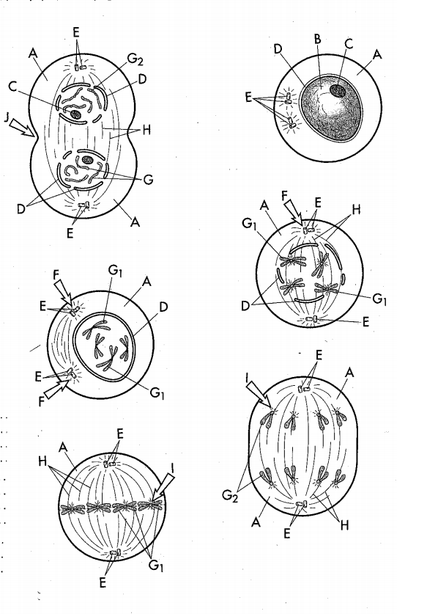
- Create a key, identifying the structures A-J. Color EACH structure the SAME color for each picture!

Meiosis vs. Mitosis Activity

MEIOSIS Directions:
- Cut out the following Meiosis diagrams; use your textbooks to glue them in the correct order on a SEPARATE sheet of paper. Draw arrows indicating the direction of the process.
- NUMBER and LABEL the Meiosis phases, including I and II under each picture. Label the cells that would be considered diploid and haploid. Not all phases are represented!!
- Color the homologous pairs the same color.
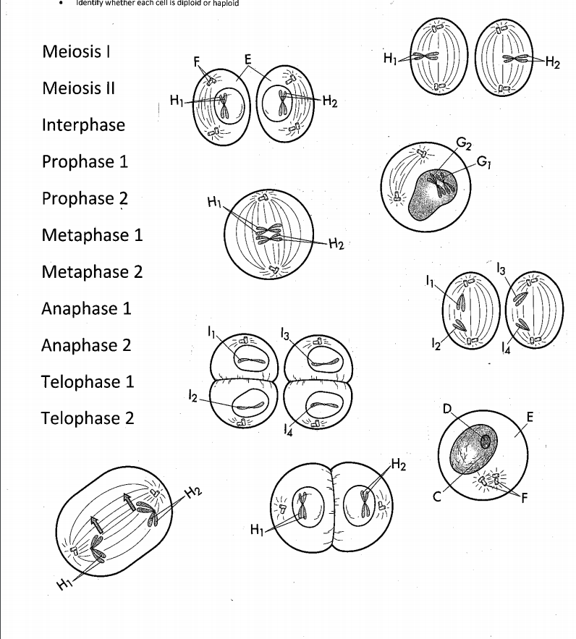
- Label the stage of Meiosis where crossing over occurs.

