Study Guide Unit 2: Biochemistry
Chapter 1: The Study of Life
Chapter 2: Chemistry in Biology
What Do I Need To Know?
SB1. Obtain, evaluate, and communicate information to analyze the nature of the relationships between structures and functions in living cells

c. Construct arguments supported by evidence to relate the structure of macromolecules (carbohydrates, proteins, lipids, and nucleic acids) to their interactions in carrying out cellular processes.
- What is the smallest particle that can retain its chemical properties?

- What is a substance that is composed of only one type of atom?

- What element must all organic compounds contain?

- Which 2 macromolecules store energy in carbon-hydrogen bonds?

- Fill in the following table:
Macromolecule | Elements | Monomer | Function | Food

- Describe what happens in a dehydration synthesis chemical reaction. Give an example.

- Describe what happens in a hydrolysis chemical reaction. Give an example.

- What is the difference between saturated and unsaturated fat? Which one is solid at room temperature and which one is liquid at room temperature?

- Identify the following macromolecule structures
______________________  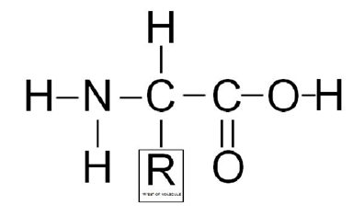 | ______________________  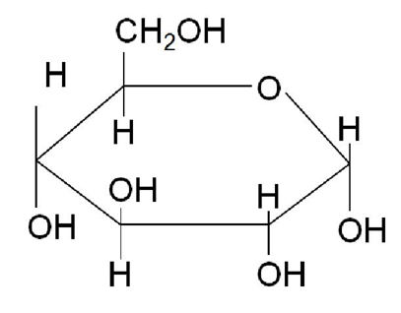 | ______________________  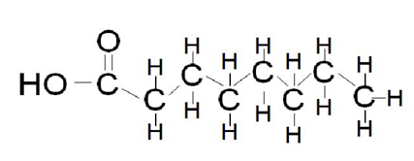 | ______________________  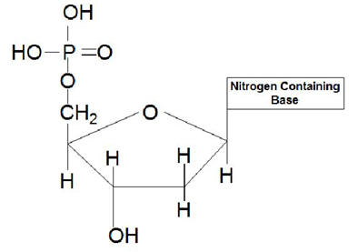
- Write the correct explanation for the following terms:
  - Disaccharide:
  - Polysaccharide:
  - Monosaccharide:
  - Peptide:
  - Polypeptide:
- What is a catalyst? What is the biological term for it?

- How does a catalyst/enzyme work to speed up reactions?

- Draw a graph and label the reactants, products, and activation energy in the color green. Next draw on the graph the reaction in the presence of a catalyst/enzyme in red.

- Draw an enzymatic reaction showing an enzyme reacting on a substrate to form a product. Label the enzyme, substrate, & active site.

- Describe how the enzyme and substrate is similar to a lock and key.

- What 3 things can affect an enzyme's function?

- What is denaturation and how does it affect the functioning of the enzyme?

- Are enzymes used up in a reaction? (Circle one) YES NO

- Explain the following bonds and give an example of each:
  - Hydrogen bond =
  - Covalent bond =
  - Ionic bond =
- What does one hydrogen (H+) ion and one hydroxide (OH-) ion combine to make?

- Explain the difference between water and oil which prevents them from mixing in the same container.

- Describe the structure of a polar molecule.

- Draw a water molecule and label the positive and negative ends.

- Which types of bonds dissolve best in water due to its polarity?
- Explain how water is an involved with dehydration synthesis chemical reactions and hydrolysis chemical reactions.

- What are Van der Waals forces and how do they apply to water properties?

- Discuss the following properties of water:
  - Cohesion:
  - Adhesion:
  - Capillary action:
  - Polarity:
- Using the properties in number 27, explain how these are vital to living organisms using humans and plants as examples.

- What makes something an acid? (Hint: what does it release in water?)

- What makes something a base? (Hint: what does it release in water?)

- What does the pH scale measure? (Hint: What does pH stand for?)

- Draw a pH scale labeling the pH range numbers, acids, bases, and neutral areas. Also, label where strong/weak bases are located and strong/weak acids.

My Biochemistry quiz is on ____________________________________________

My Unit 1 Biochemistry test is on ____________________________________________________

What should I use to study for my test?
- Powerpoint notes
- This study guide
- Handouts given in class
- My quiz
- Review concepts: global warming, population growth rate, exponential v. logistic, 10% rule, food webs, niches, dependent v. independent variables

