Name:________________________________ Date:________________________ Period:____________

Unit 1: Ecology
- What is a biotic factor? Give an example
- What is an abiotic factor? Give an example
- List and give examples of the levels of organization in ecology IN ORDER.
- If a giraffe is an individual organism, what would a group of 15 giraffes be referred to as?
- What is a niche? How is this different from an organism’s habitat?
- If 2 niches overlap for 2 different types of organisms, what does that lead to?
- Fill out the chart below for the 3 types of symbiotic relationships.
Type of Symbiosis | Description | Example

- Describe the predator vs. prey relationship.
- How does one population size affect the other?
- What are the types of decomposers?
a. What role do decomposers play in the environment as it relates to the cycling of nutrients?
- What is the ultimate source of energy for living things on earth?
- Define what is a producer/autotroph and give an example.
- Define what is a consumer/heterotroph and give an example.
- What do the levels on the trophic pyramid represent?
- DRAW and LABEL an energy pyramid with 4 trophic levels included. Provide examples of organisms in 4 levels of the energy pyramid OR DRAW and LABEL organisms in a food chain with 4 trophic levels included.

- Explain the 10% energy rule. (how much energy is available at each succeeding level in an energy pyramid & what happens to the rest).

- What does the direction of the arrows in food chains or webs indicate?

- Compare the number of organisms at the top of an energy pyramid to those at the bottom and explain why there is a difference.
- How could a change in the number of primary consumers affect the population size of the secondary consumers?
a. How would that change in the primary consumer population size affect the number of producers?
- What is the difference between a food web and a food chain?

- Define biomass.

- Define keystone species.
a. Give an example of a keystone species and state why it is a keystone species for its ecosystem.
- Explain how nutrients are recycled through each of the 5 biogeochemical cycles (C, N, O, P, H₂O).

- Draw a BASIC visual representation of each of the 3 nutrient cycles (carbon, nitrogen, phosphorus).

- Describe the stages of the hydrologic cycle (water cycle) listed below.
A. Evaporation:
B. Condensation:
C. Precipitation
D. Transpiration:
E. Runoff:
- Carbon Cycle in Ecosystems
a. Carbon is most commonly found in the form of ________ gas in the atmosphere
b. Carbon is primarily released into the atmosphere by…
c. Atmospheric carbon is primarily absorbed by…
d. Which human activity releases the MOST carbon into our atmosphere?
- Nitrogen Cycle in Ecosystems
  - Define and describe the process of nitrogen fixation:
  - Why is nitrogen fixation an important process?
  - Most nitrogen on earth is found in the form of ______________________.
  - Organisms need nitrogen to make _____________ but cannot use its most common form.
  - The ____________________________________________ are responsible for making this common form of nitrogen usable by other living organisms.
  - Define and describe the process of denitrification:
  - How do humans get the amount of nitrogen that we need?
- What is the difference between renewable and non-renewable resources? Give 2 examples of each.

- Explain the process of global warming, be sure to include how it is different from the Greenhouse Effect.
a. How do greenhouse gases fit within the 5 biogeochemical cycles?

- a. Analyzing the graphs below, what pattern(s) is/are shown in the graph of Temperature Anomaly over time from 1880 to 2020?
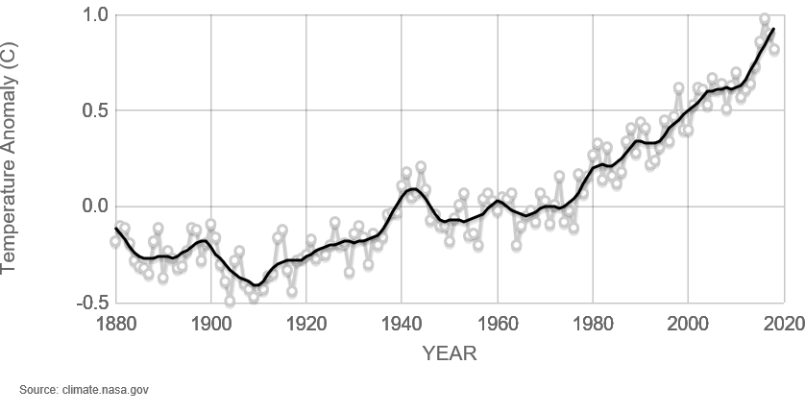

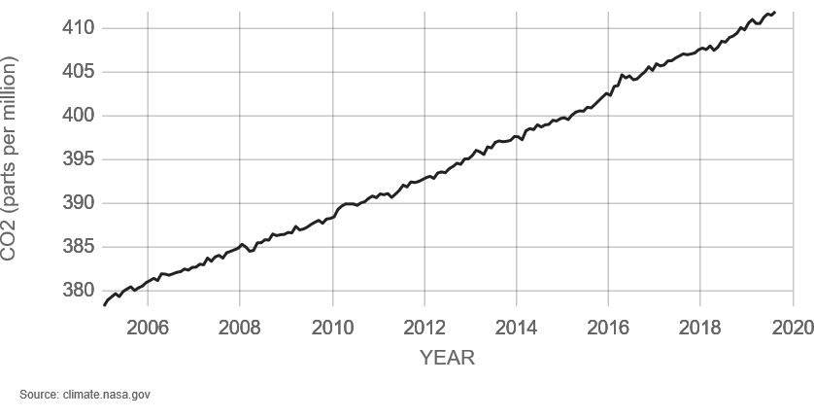
b. What pattern(s) is/are shown in the graph of CO2 over time from 2006 to 2020?
c. What interpretations can be made by comparing these graphs?

30. What is the difference between primary and secondary succession?

31. What is the difference between pioneer species and climax community? Give an example of each to illustrate the difference.

32. Describe the plants and animals that would be present in 4 stages of primary succession within a typical ecosystem in Georgia. Be sure to label which is the pioneer species and which stage is the climax community.

33. What causes competition between organisms in a population? What would cause competition to increase?

34. Organism Population
a. Describe the 3 types of spatial distribution.
b. What is a limiting factor? Give an example.

35. Draw a logistic model of population growth graph. What does it represent?

36. Draw an exponential model of population growth graph. What does it represent?
37. What is carrying capacity?
d. What happens to a population if the size exceeds its carrying capacity?
38. Create a Venn Diagram or chart to compare and contrast density-dependent & density-independent limiting factors. Give examples of each within your chart/diagram.

