NAME: ___________________________________DATE:__________________ Period:____________

DNA - The Double Helix
Recall that the nucleus is a small spherical, dense body in a cell. It is often called the "control center" because it controls all the activities of the cell including cell reproduction, and heredity. How does it do this? The nucleus controls these activities with chromosomes. Chromosomes are microscopic, threadlike strands composed of the chemical DNA. In simple terms, DNA controls the production of proteins within the cell. These proteins in turn, form the structural units of cells and control all chemical processes within the cell. Think of proteins as the building blocks for an organism, proteins make up your skin, your hair, and parts of individual cells. How you look is largely determined by the proteins that are made. The proteins that are made is determined by the sequence of DNA in the nucleus.

Chromosomes are composed of genes. A gene is a segment of DNA that codes for a particular protein, which in turn codes for a trait. Hence you hear it commonly referred to as the gene for baldness or the gene for blue eyes. Meanwhile, DNA is the chemical that genes and chromosomes are made of. It stands for deoxyribonucleic acid. DNA is called a nucleic acid because it was first found in the nucleus. We now know that DNA is also found in organelles, the mitochondria and chloroplasts, though it is the DNA in the nucleus that actually controls the cell's workings.

In 1953, James Watson and Francis Crick established the structure of DNA. The shape of DNA is a double helix, which is like a twisted ladder. The sides of the ladder are made of alternating sugar and phosphate molecules. The sugar is deoxyribose.
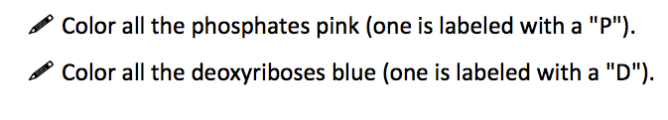
(pentagons are deoxyriboses)
(circles are phosphates)
The rungs of the ladder are pairs of 4 types of nitrogen bases. Two of the bases are purines- adenine and guanine. The pyrimidines are thymine and cytosine. The bases are known by their coded letters A, G, T, C. These bases always bond in a certain way. Adenine will only bond to thymine. Guanine will only bond with cytosine. This is known as the "Base-Pair Rule". The bases can occur in any order along a strand of DNA. The order of these bases is the code that contains the instructions. For instance ATGCACATA would code for a different gene than AATTACGGA. A strand of DNA contains millions of bases. (For simplicity, the image only contains a few.)
Color the DNA and replication model on the BACK of this activity, using the key that you create below. Notice that several nucleotides are floating around in the image; they are waiting to pair up with their match.
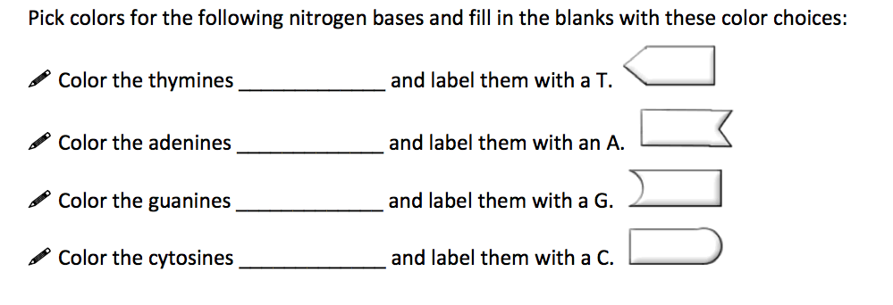
**Note that that the bases attach to the sides of the ladder at the sugars and not the phosphate.

The DNA helix is actually made of repeating units called nucleotides. The combination of a single base, a deoxyribose sugar, and a phosphate make up a nucleotide. Color the nucleotides in the box using the same colors you used for the double helix.

The two sides of the DNA ladder are held together loosely by hydrogen bonds, which are weak bonds. (see the spaces down the middle of the double helix). The DNA can actually "unzip" when it needs to replicate - or make a copy of itself. DNA needs to copy itself when a cell divides, so that the new cells each contain a copy of the DNA. Without these instructions, the new cells wouldn't have the correct information.

The Blueprint of Life
Every cell in your body has the same "blueprint" or the same DNA. Like the blueprints of a house tell the builders how to construct a house, the DNA "blueprint" tells the cell how to build the organism. Yet, how can a heart be so different from a brain if all the cells contain the same instructions? Although much work remains in genetics, it has become apparent that a cell has the ability to turn off most genes and only work with the genes necessary to do a job. We also know that a lot of DNA apparently is nonsense and codes for nothing. These regions of DNA that do not code for proteins are called "introns", or sometimes "junk DNA". The sections of DNA that do actually code from proteins are called "exons".
Questions:

- Write out the full name for DNA.

- Why is the nucleus called the “control center” of the cell?

- Where in the cell are the chromosomes located?

- What is a gene?

- What do proteins do for your body?

- What two scientists established the structure of DNA?

- What are the sides of the DNA ladder made of?

- What three parts make up a single nucleotide?

- What are the 4 bases that make up the rungs of the DNA ladder?

- What sugar is found in DNA?

- How do the bases bond together in DNA?

- What is the process of copying DNA called?

- What is the shape of DNA? What holds the sides of the DNA ladder together?

- Why is DNA called the “Blueprint of Life”? What is the difference between introns and exons?

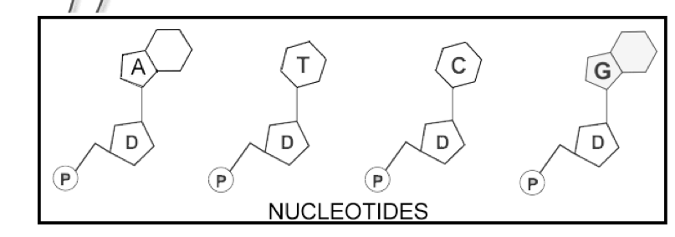

DNA Replication
Each time a new cell is made, the cell must receive an exact copy of the parent cell DNA. The new cells then receive the instructions and information needed to function. The process of copying DNA is called replication. Replication occurs in a unique way- instead of copying a complete new strand of DNA, the process “saves” or conserves one of the original strand. When the DNA is ready to copy, the molecule “unzips” itself, with the help of the enzyme DNA helicase and new nucleotides are added to each side by the enzyme DNA polymerase.
- Color the DNA replication spit below, by coloring the OLD backbone strands red and the NEW strands green.
- Color the bases, according to the original key on the first page.
- Color the hydrogen bonds gray between the 2 strands. Label where you would find the enzymes DNA helicase AND DNA polymerase, based on their functions.
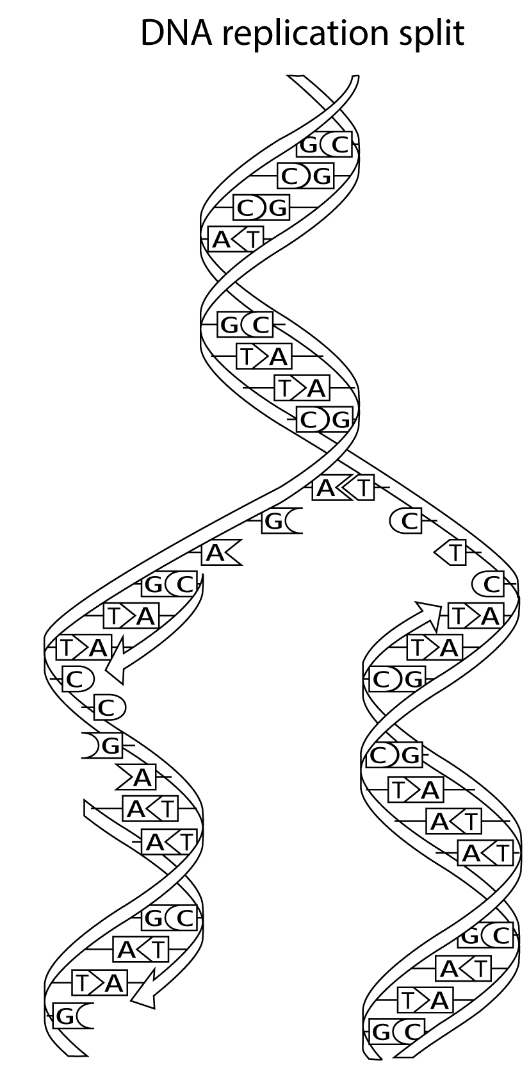
Color the DNA and replication model below, using the key from the FIRST page. Notice that several nucleotides are floating around in the image; they are waiting to pair up with their match.
The boxed section at the bottom shows two new strands of DNA. Color the old strands (including their half of the nitrogen bases, or “ladder rungs”) red and the new strand (including their half of the nitrogen bases) green. **DNA Replication results in two DNA molecules, each with one new strand and one original strand.

