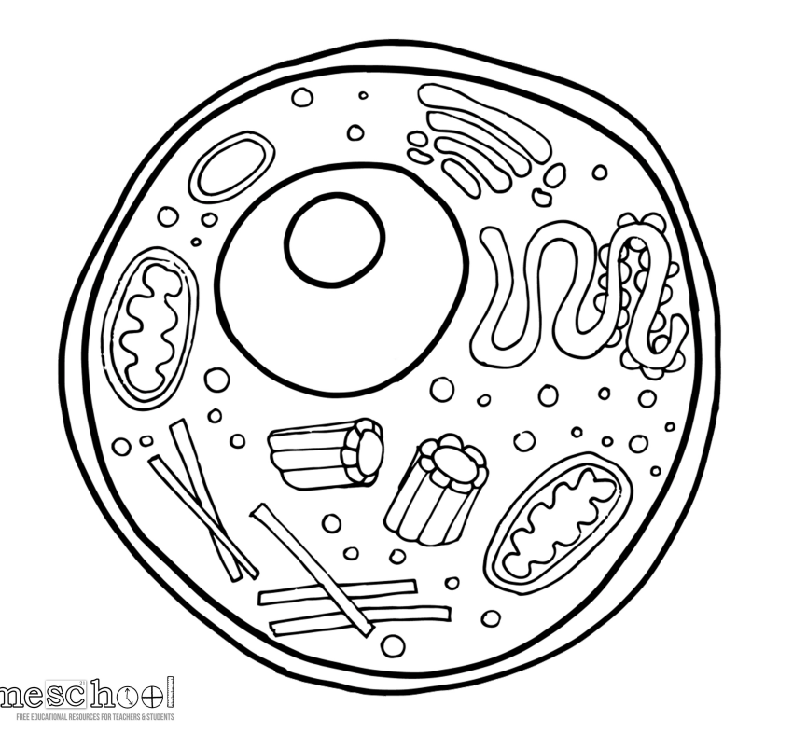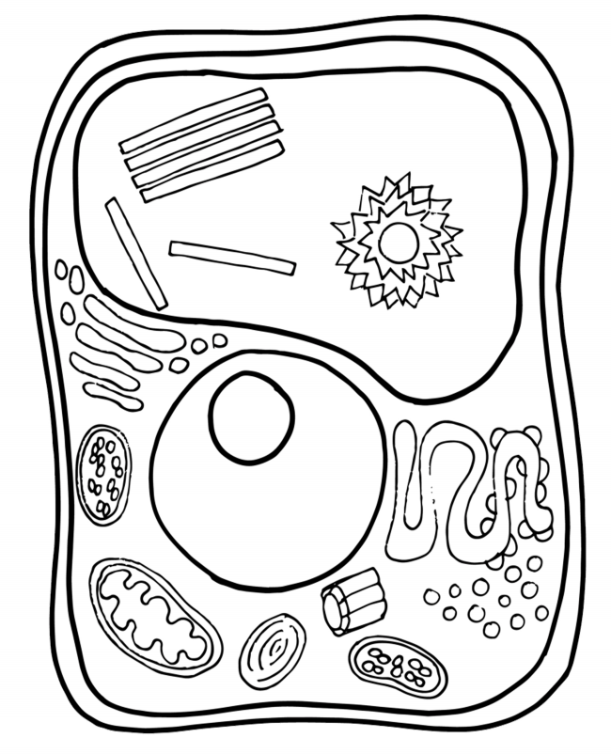

**Cell Wall**

Cell membrane

Golgi Body

Endoplasmic

Reticulum

Ribosome

**Vacuole**\*\*

**Lysosome**

Nucleus

Mitochondria

**Chloroplast**

**Centriole**

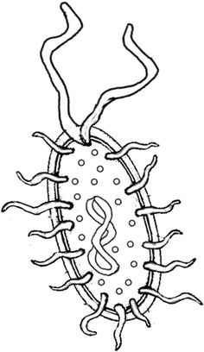

**Bacterial Cells**

Cell Wall

Cell Membrane

Cytoplasm

DNA

Ribosomes

Flagella

Pili

**Animal Cells**

**Lysosome**

**Centriole**

**Plant Cells**

**3 C’s**

1. **Cell wall**
2. **\*\*Central Vacuole**
3. **Chloroplast**