Go to www.johnbio.weebly.com, download the Biotechnology Online Lab and click on each link for all parts of this lab. Click on the link name of each part for the website to pop up.**You MAY need to use Internet Explorer to view animations! You will write your answers on the paper. You will turn this paper in when completed for a 50 points lab grade.

Part 1: Click and Clone

1. What are the 6 steps to clone Mimi the mouse?
a.

b.

c.

d.

e.

f.

2. What is a somatic/cumulus cell?

3. Is it diploid or haploid?

4. What color is Mini-Mimi, Mimi’s clone?

5. What 2 cells were necessary to clone Mimi?

6. What is a clone?
______________________________________________________________________
Part 2: DNA Fingerprinting
Read the Introduction, then click on Part 1: It Takes a Lickin’

- Summarize the “crime”.

- Describe the “suspects”

- What must be created to solve the crime?
Click on Part 2: DNA Fingerprinting at the NOVA Lab (if having trouble loading then click on the link below) https://docs.google.com/document/d/1oZwqkajjJT1ox7GZMyw0enOx7M6VhR-fR-FuJ9681Is/edit?usp=sharing

- Write down the steps as you work through the steps of creating a “Gel Electrophoresis”

STEP 1 –

a. What is the purpose of restriction enzymes?

b. What is important about the length of the fragments the restriction enzymes create?

STEP 2 –

a. What is agarose gel? What’s its purpose?

STEP 3 –

STEP 4 –

a. What is “electrophoresis”?

b. Explain HOW and WHY the DNA migrates down the tray (HINT: This has to do with the CHARGE of DNA.)

c. Compare the final destination of large fragments compared to small ones.

STEP 5 –

STEP 6 –

STEP 7 –

a. What is the relationship between steps 6 and 7?

STEP 8 –

4. Based on the DNA Fingerprint and the saliva sample, who was the culprit?

5. Why is this pattern made by DNA called a “fingerprint”?

Part 3: Gene Therapy

Click on “WHAT IS GENE THERAPY”, then answer the questions below
- Describe gene therapy.

- How is gene therapy different from traditional approaches?

- What is a vector? (The answer is NOT just a virus!)

- What conditions are MOST likely to be helped with gene therapy?

Navigate back to the original Gene Therapy page, then select “GENE DELIVERY: TOOLS OF THE TRADE”, then complete the table below
i. For each “VECTOR” below, describe HOW it aids in gene therapy
HINT: Click next to the vector picture to navigate back to the toolbox each time.

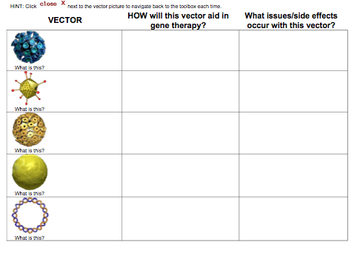

Part 4: Engineer a Crop
Click on Engineer a Crop. Read the information, then click on the Transgenic Manipulation Simulation.

- How do you create a transgenic plant?

- Write down each step:
  - STEP 1:

  - STEP 2:

  - STEP 3:

  - STEP 4:

  - STEP 5:

  - STEP 6:

  - STEP 7:

  - STEP 8:

- How was the plant tested to see if it was resistant to the pest?

Part 5: Guess What’s Coming to Dinner?
Click on 3 items in the picture and describe how they are genetically modified.
  - FOOD ITEM 1:

  - FOOD ITEM 2:

  - FOOD ITEM 3:

Part 6: Should We Grow GM Crops?
- What does GM stand for?
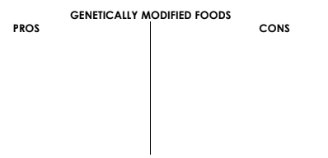
- Fill in the table as you work through the arguments for & against
GM Foods.
- After finishing the activity, are you PRO or CON Genetically
Modified Foods?
CIRCLE ONE: PRO CON

- Explain WHY you feel this way.

