Name:________________________________ Date:________________________ Period:____________

Unit 2: Biochemistry

1. What element must all organic compounds contain?_______________________________________

2. Which 2 macromolecules store energy in carbon-hydrogen bonds?___________________________
_____________________________________________________________________________________
3. Fill in the following table:
Macromolecule | Elements | Monomer | Function | Food
4. Identify the following macromolecule structures:
A. _________________________  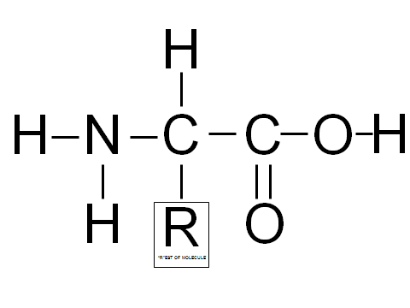 | B. ___________________________  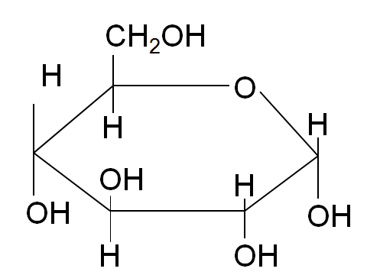
C. ___________________________  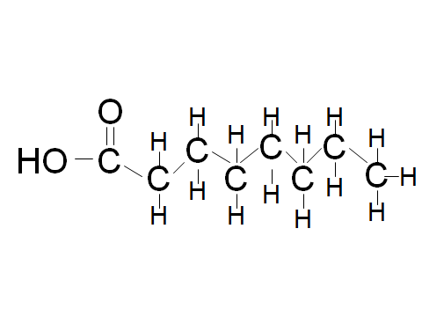 | D. ____________________________  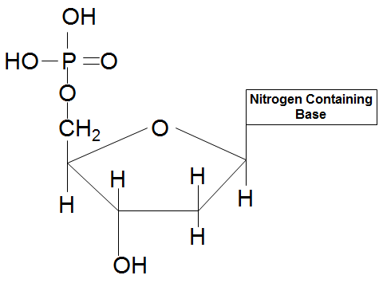

5. Write the correct explanation for the following terms; Write an example of each.

- Disaccharide:____________________ _______________________________
- Polysaccharide:__________________
__________________________________
- Monosaccharide:________________________
_______________________________________
- Polypeptide:______________________________

6. What types of tests are used to show the presence of the following molecules of life?
Simple carbohydrates:__________________________________ Proteins:_________________________
Complex carbohydrates:_________________________________ Lipids:__________________________

7. How does a catalyst/enzyme work to speed up reactions?____________________________________
__________________________________________________________________________________________________________________________________________________________________________
8. Why does our body need enzymes?______________________________________________________
_____________________________________________________________________________________

9. Describe how the enzyme and substrate is similar to a lock and key.___________________________
_____________________________________________________________________________________

10. Draw a graph and label the reactants, products, and activation energy in the one color. Next draw on the graph the reaction in the presence of a catalyst/enzyme in a different color.

11. Draw an enzymatic reaction showing an enzyme reacting on a substrate to form a product. Label the enzyme, substrate, & active site.

12. What 3 things can affect an enzyme’s function?____________________________________________
_____________________________________________________________________________________

13. What is denaturation and how does it affect the functioning of the enzyme?___________________
__________________________________________________________________________________________________________________________________________________________________________
14. Are enzymes used up in a reaction?(Circle one) YES NO
15. What changes in a chemical reaction, the enzyme or the substrate? Explain your answer.__________
_____________________________________________________________________________________
16. What does the pH scale measure?_____________________________________________________
____________________________________________________________________________________

17. Draw a pH scale labeling the pH range numbers, acids, bases, and neutral areas. Also, label where strong/weak bases are located and strong/weak acids.

18. What does one hydrogen (H+) ion and one hydroxide (OH-) ion combine to make?________________
19. What types of bonds hold water molecules together?_______________________________
20. Define homeostasis. What is an example of the human body maintaining homeostasis?___________
_____________________________________________________________________________________
21. What is the independent variable? Where is it located on a graph?____________________________
_____________________________________________________________________________________

22. What is the dependent variable? Where is it located on a graph?______________________________
_____________________________________________________________________________________
23. What is the control group in an experiment?______________________________________________
_____________________________________________________________________________________
Ecology REVIEW items to remember for the test!!

- Predator-Prey relationships
- Primary vs. secondary succession
- Density dependent vs. independent limiting factors
- Greenhouse effect and Global Warming
- Food Webs and the effect of changes in population size

