The Spill video
http://video.gpb.org/video/2365202622/

Essay question: How were populations (including humans) affected by the spill?

https://www.ted.com/talks/siddhartha_roy_science_in_service_to_the_public_good
environmental decision making Video

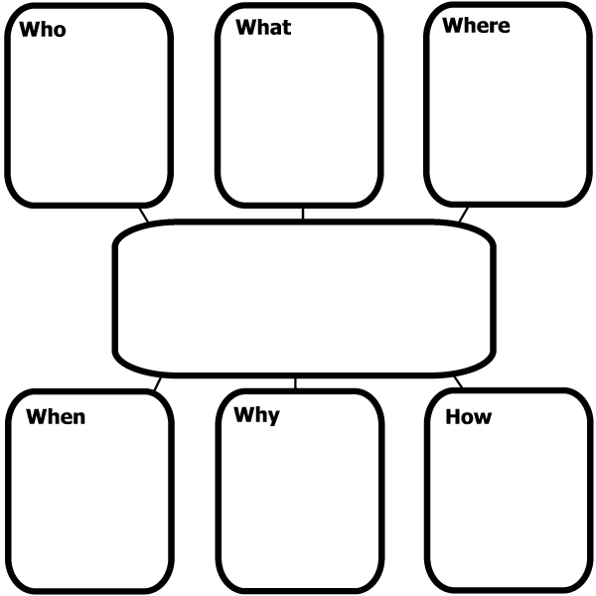
How were the living things impacted?
Why is the spill such a problem for all of us, not just the Gulf Coast?
What living things were impacted?
What nonliving things were affected?
“The Spill”
Other Important Facts

